

Name: Muhammad Faisal
Roll no: 2022F-BCS-152

Section: D
Instructor Name: Sir Abdul Khaliq Course: Programming Fundamentals - 2035 Course Code: CS116L - 2035C
Program: (BS) - Computer Science
Session: Fall 2022

Task 1: Write a C++ program to take input from the user and display it on the screen.
Code
nclude < ostream.h> us ng namespace std;
nt ma n()
{
cout<<"Input Appl cat on \n"; char name;
cout<<"\nEnter your name: "; c n>>name;
}

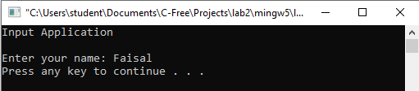
Output

Task 2: Write a C++ program to take input from user and calculate its square-root.

Code
nclude < ostream.h> us ng namespace std;
nt ma n()
{
cout<<"Square Appl cat on \n"; nt a,square;
cout<<"\nEnter Value: "; c n>>a;
square=a*a;
cout<<"The square of g ven value s: "<<square<<endl;
}

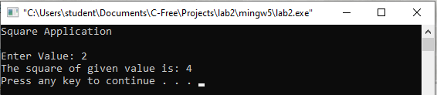
Output

Task 3 Write a C++ program that asks the user to enter two numbers, obtains the two numbers from the user, and prints the sum, product, difference, and quotient of the two numbers.
Code
nclude < ostream.h> us ng namespace std;
nt ma n()
{
cout<<"Calculator Appl cat on\n"; nt a,b,sum,sub,mult ply,d v de;
cout<<"\nEnter f rst Value\n"; c n>>a;
cout<<"Enter socond value\n"; c n>>b;

sum=a+b; sub=a-b;
mult ply=a*b; d v de=a/b;

cout<<"\n Result of addt on s: "<<sum; cout<<"\n Result of subtract on s: "<<sub;
cout<<"\n Result of mult pl caton s: "<<mult ply; cout<<"\n Result of d vs on s: "<<d vde<<endl; return 0;
}

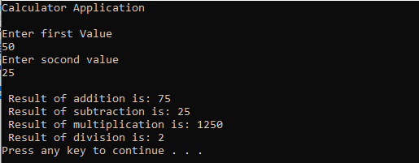
Output

Task 4: Write a program to take two numbers as input from user and return swap results.

Code
nclude < ostream> us ng namespace std;
nt ma n()
{
cout << "Swap Results Appl cat on\n"; nt a, b, temporary;
cout << "\nEnter value a\n"; c n >> a;
cout << "Enter value b\n"; c n >> b;
temporary = a; a = b;
b = temporary;
cout << "After Swapp ng" << endl;
cout << "a=" << a << ", b=" << b << endl; return 0;
}

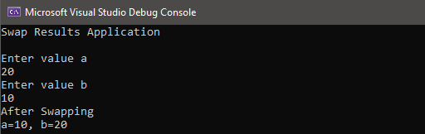
Output

Task 5: Write a C++ program that takes the temperature in Fahrenheit as an input argument and returns the centigrade temperature.

Code
nclude < ostream> us ng namespace std;
nt ma n()
{
cout<<"Convers on from Fahrenhe t to Cent grade Appl cat on\n"; float c, f;
cout << "\nEnter temperature n Fahrenhe t \n"; c n >> f;
c = 5 * (f - 32) / 9;
cout <<"After convers on, the temperature n Cent grade s "<<c<<endl; return 0;
}

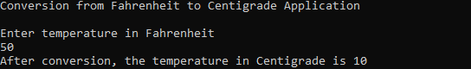
Output
Lab Session 1
Task 1: What is the output from the following C++ code fragment?
nclude < ostream> us ng namespace std;
nt ma n(vo d)
{
cout<<"\nSr Syed Un vers ty of Eng neer ng and Technology"<<endl; cout<<"\t \n programm ng fundamentals us ng C++" <<endl;
return 0;
}
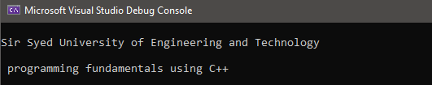
Output

Lab Session 2 (In-Lab Tasks)

Task 1: What will be the output of the following C++ code fragment?
nclude < ostream> Us ng namespace std;
nt ma n ()
{
cout << "Hello World! "; // pr nts Hello World!
cout << "I'm a C++ programmer"; // pr nts I'm a C++ program return 0;
}
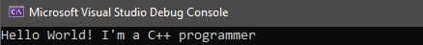
Output


Task 2: Find out errors (if any) in the following C++ program
- nclude< ostream>
- usng namespace std;
- vod ma n()
- { /* Th s s the ma n functon
- cout<<'C++ flrogramm ng quest ons and answers'; 6. }

Errors

(line 3) return type of ‘main’ should be ‘int’ instead of ‘void’
- (line 4) comment unclosed
- (line5) double quotes should be used instead of single quotes to print a statement

Task 3: Write down the output of the following code in the box
nclude < ostream> us ng namespace std;
nt ma n()
{
nt num1, num2; nt sale;
char f rst;
num1 = 4; cout << "num1 = " << num1 << endl; num2 = 4 * 5 - 11;
cout << "num2 = " << num2 << endl; sale = 2 * 1000;
cout << "sale = " << sale << endl; return 0;
}
Output
num1 = 4
num2 = 9
sale = 2000

Lab Session 2 (Post-Lab Tasks)
Task 1: Write C++ code, in which initialize two variable a and b with 44 and 56. Print addition, subtraction, division and multiplication of a with b.
Code
nclude < ostream> us ng namespace std;
nt ma n()
{
nt sum, mult ply, sub, d v de; nt a = 44, b = 56;
sum = a + b; sub = a - b;
d v de = a / b; mult ply = a * b;
cout << "Sum of a and b s " << sum << endl;
cout << "Subtract on of a and b s " << sub << endl; cout << "D v s on of a and b s " << d v de << endl;
cout << "Mult pl cat on of a and b s " << multply << endl; return 0;
}

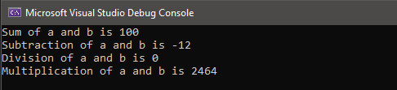
Output

Task 2: Write down C++ code of following. Create two variables T and U. Initialize variables with 5 and 2. Print square of T and U (square is simple multiplication of T*T or U*U).

Code
nclude < ostream> us ng namespace std;
nt ma n()
{
nt square1, square2; nt t = 5, u = 2;

square1 = t * t; square2 = u * u;

cout << "Square of t s " << square1 << endl; cout << "Square of u s " << square2 << endl; return 0;
}

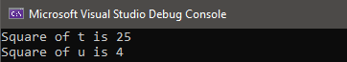
Output

Task 3: Write a C++ program that calculates the area of a rectangle as per the formula shown (Area = base x height). The values of base and height are 5 and 8 respectively.

Code
nclude < ostream> us ng namespace std;
nt ma n()
{
nt area;
nt b = 5, h = 2; area = b * h;
cout << "Area of rectangle s " << area << endl; return 0;
}

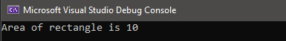
Output

Task 4: Write C++ code, in which the length & breadth of a rectangle are 13 and 14. Also, the radius of a circle is 10. Write a program to calculate the area & perimeter of the rectangle and the area & circumference of the circle.

Code
nt ma n()
{
nt area_rect, per meter_rect, area_c rcle; float permeter_c rcle, y=3.14;
nt l = 13, b = 14, r=10, x=2;

area_rect = l * b;
per meter_rect = (x * l) + (x * b); area_c rcle = y * (r * r);
per meter_c rcle = x * y * r;

cout << "Area of rectangle s " << area_rect << endl;
cout << "fler meter of rectangle s " << per meter_rect << endl; cout << "Area of c rcle s " << area_c rcle << endl;
cout << "fler meter of crcle s " << per meter_c rcle << endl; return 0;
}

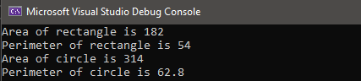
Output

Task 5: Write a C++ program that takes obtained marks of a student in five different subjects, each subject has maximum 100 numbers. Calculate total numbers (Obtain numbers out of 500) and percentage of student and print it on the output screen.

Code
nclude < ostream> us ng namespace std;
nt ma n()
{
float sub1, sub2, sub3, sub4, sub5, total, per;

cout << "Enter marks obta ned n subject 1 " << endl; c n >> sub1;
cout << "Enter marks obta ned n subject 2 " << endl; c n >> sub2;
cout << "Enter marks obta ned n subject 3 " << endl; c n >> sub3;
cout << "Enter marks obta ned n subject 4 " << endl; c n >> sub4;
cout << "Enter marks obta ned n subject 5 " << endl; c n >> sub5;

total = sub1 + sub2 + sub3 + sub4 + sub5; per = (total / 500) * 100;

cout << "Total marks obta ned n all 5 subjects " <<total<< endl; cout << "flercentage of all 5 subjects " << per << endl;
return 0;
}

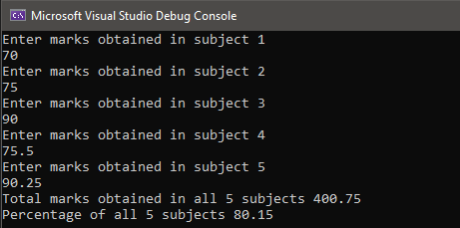
Output

Task 6: Write down output of following code in box

Code
nclude < ostream> us ng namespace std;
nt ma n()
{
nt a = 3, b = 4;
cout << "a= " << a << " b= " << b << endl; a = 6;
cout << "a= " << a << " b= " << b << endl; b = 9;
cout << "a= " << a << " b= " << b << endl; a = 0;
b = 0;
cout << "b= " << b << " b= " << b << endl; return 0;
}

Output
a= 3 b= 4
a= 6 b= 4
a= 6 b= 9
b= 0 b= 0

Task 7: Find out errors in the following C++ programs:
- 1. nclude <ostream>
  - us ng namespace std;
  - nt (ma n) 4. {
- cout << "Hello, World!";
- cout << 'S r Syed Un vers ty of Engneerng and Technology';
- cout << "COMflUTER SCIENCE",
- Cout << "flROGRAMMING FUNDAMENTALS";
- return 0; 10.}

Errors

(line 3) ‘main’ cannot be used as global variable name
- (line 6) double quotes should be used instead of single quotes to print a statement

(line 7) semicolon ; should be used instead of coma , to print a statement
- (line 8) c of cout should be in small letter

- 1. nclude [ ostream]
2. nt ma n() 3. {
- std::cout << "Hello,World!".
- return 0; 6. }

Errors

(line 1) < > should be used instead of [ ]
- (line 4) semicolon ; should be used instead of full stop to print a statement

Lab Session 3 (In-Lab Tasks)
Task 1: Write a program that takes four floating numbers from the keyboard and prints their sum, product, and average.
Code
nclude < ostream> us ng namespace std;
nt ma n()
{
float sum, product, average; float a, b, c, d;

cout << "Enter four values" << endl; c n >> a >> b >> c >> d;

sum = a + b + c + d; product = a * b * c * d; average = sum / 4;

cout << "Sum of four values entered s " << sum << endl;
cout << "flroduct of four values entered s " << product << endl; cout << "Average of four values s " << average << endl; return 0;
}

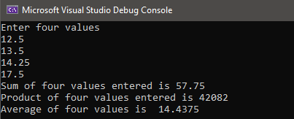
Output

Task 2: Write a program to calculate the area of the circle, taking the value of the radius from the user.

Code
nclude < ostream> us ng namespace std;
nt ma n()
{
float area_c rcle, r;
cout << "Enter value of rad us\n"; c n >> r;

area_c rcle = 3.14 * (r * r);

cout << "Area of c rcle s " << area_c rcle << endl; return 0;
}

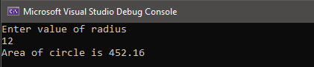
Output


Task 3: Write a program that prints to calculate the age in days by using the formula: days = years * 365.

Code
nclude < ostream> us ng namespace std;
nt ma n()
{
nt days, years;
cout << "Enter your age\n"; c n >> years;
days = years * 365;
cout << "Your age n days s " << days << endl; return 0;
}

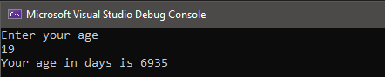
Output

Task 4: Write a C++ program to convert temperature from degree Celsius to Fahrenheit.

Code
nclude < ostream> us ng namespace std;
nt ma n()
{
cout << "Convers on from Cels us to Fahrenhe t Appl cat on\n"; float c, f ;
cout << "\nEnter temperature n Celsus \n"; c n >> c;
f = (c * 9 / 5) + 32;
cout << "After convers on, the temperature n Fahrenhe t s " << f; return 0;
}
Output
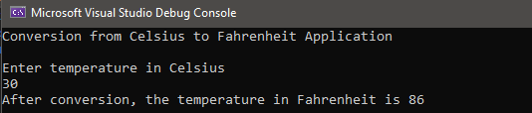

Lab Session 3 (Post-Lab Tasks)
Task 1: Write a C++ program that takes a person’s weight in KG, and converts it into pounds. Your program should output both weights. (Note that 1 KG is 2.2 pounds.)
Code
nclude < ostream> us ng namespace std;
nt ma n()
{
cout << "Convers on from KG to flound Appl cat on\n"; float kg, p ;
cout << "\nEnter we ght n KG \n"; c n >> kg;
p = 2.2 * kg;
cout << "We ght n KG s " << kg <<endl; cout << "We ght n pounds s " << p; return 0;
}

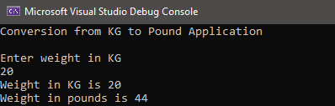
Output

Task 2: A cashier has currency notes of denominations 10, 50 and 100. If the amount to be withdrawn is input through the keyboard in hundreds, find the total number of currency notes of each denomination the cashier will have to give to the withdrawer. Write a C++ program to implement the above scenario.

Code
nclude < ostream> us ng namespace std;
nt ma n()
{
nt amount, t, f, h;
cout << "Enter the amount to be w thdrawn n hundreds\n"; c n >> amount;
h = amount / 100; f= amount / 50;
t = amount / 10;
cout << "Currency note n denomnat ons 10 are: " << t << endl; cout << "Currency note n denomnat ons 50 are: " << f << endl; cout << "Currency note n denomnat ons 100 are: " << h << endl; return 0;
}

Output
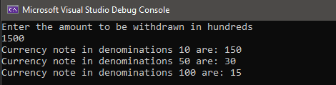

Task 3: Write a C++ program that calculates the monthly salary of an employee. The salary is calculated after the deduction of the following taxes. Income Tax: 10%. Global Life Insurance: 2.75%. Pension Plan: 2.3%. Health Insurance: 200.0 rupees. Your program should prompt the user to input the gross amount and your program should show each tax and net salary (after tax deduction). Your output should be in the same format (not the same values) as shown in the example below.

Code
nclude < ostream> us ng namespace std;
nt ma n()
{
nt salary, total, reduct on; float , l, p, h;
cout << "Enter Gross amount of employee(RS. ):\n"; c n >> salary;

= (10.0 / 100) * salary; l = (2.75 / 100) * salary; p = (2.3 / 100) * salary; h = 200.0;
total = + l + p + h; reduct on = salary - total;

cout << "Income Tax (RS.): " << << endl;
cout << "Global Lfe Insurance(RS.): " << l << endl; cout << "flenson fllan (RS.): " << p << endl;
cout << "Health Insurance (RS.): " << h << endl;
cout << "Net Salary (after tax deduct on) (Rs. ): " << reduct on << endl;

return 0;
}

Output
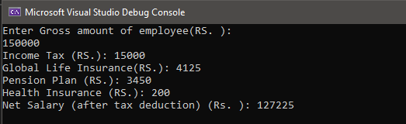

Task 4: Write a C++ program that takes a 5-digit number in variable X. Your program should store the reverse of entered number into variable Y. You program should also print it on screen.

Code
nclude < ostream> us ng namespace std;
nt ma n()
{
nt num, reverse, d1, d2, d3, d4, d5; cout << "Enter 5 d g t value\n";
c n >> num;
f (num >= 10000 && num <=99999) { d5 = num % 10;
num = num / 10; d4 = num % 10; num = num / 10; d3 = num % 10; num = num / 10; d2 = num % 10; d1 = num / 10;
reverse = d5 * 10000 + d4 * 1000 + d3 * 100 + d2 * 10 + d1; cout << "Output: " << reverse;
}
else {
cout << "Number s nval d";
}
return 0;
}

Output
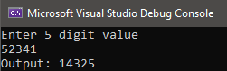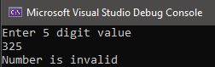

Lab Session 4 (In-Lab Tasks)
Task: 1 Mention the output for the following program
- nclude<std o.h>
- vod ma n() 3. {
4. nt a = 100;
5. f (a > 10)
- cout << "Shah d Afr d ";
- else f (a > 20)
- cout << "Shoa b Akhtar";
- else f (a > 30)
- cout << "Kamran Akmal";
11. }
Output
There are several errors in this program therefore the program will not run and there will be no output
- (line 1) <iostream> should be used instead of <stdio.h>. #include<iostream> tells the processor to include the contents of the file <iostream>
- (line 2) return type of ‘main’ should be ‘int’ instead of ‘void’ because the void main() indicates that the main() function will not return any value, but the int main() indicates that the main() can return integer type data.
- (line 6, 8, 10) std:: is missing before cout. We need std:: to specify what “namespace” cout belongs to.
Task 2: Write a program that takes a number as input from the user and checks whether the number is even or odd Using if-else.

Code
nclude < ostream> us ng namespace std;
nt ma n()
{
nt ;
cout << "Enter the value\n"; c n >> ;

f ( % 2 == 1) {
cout << << " s an odd number" << endl;
}
else {
cout << << " s an even number" << endl;
}
}

Output
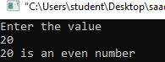
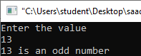

Task 3: Write a program that declares and initializes two numbers with your_roll_no and your_friend_roll_no and displays the greater of the two.

Code
nclude < ostream> us ng namespace std;
nt man()
{
nt your_roll_no, your_frend_roll_no; cout << "Enter your roll number\n";
c n >> your_roll_no;
cout << "Enter your fr end's roll number\n"; c n >> your_fr end_roll_no;

f (your_roll_no > your_fr end_roll_no) {
cout << "Your roll no s greater" << endl;
}
else {
cout << "Your fr end's roll no s greater" << endl;
}
return 0;
}

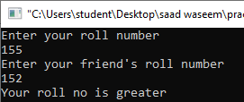
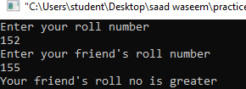
Output
Task 4: Write a program to read the age of a candidate and determine whether it is eligible for casting his/her own vote.

Code
nclude < ostream> us ng namespace std;
nt ma n()
{
nt age;
cout << "Enter your age\n"; c n >> age;

f (age >= 18) {
cout << "You are el g ble to caste a vote" << endl;
}
else {
cout << "You are unel gble to caste a vote" << endl;
}
return 0;
}

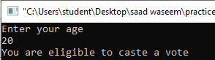
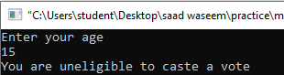
Output

Task 5: Write a C++ program to enter three numbers from the user and display the greatest value among all three values.

Code
nclude < ostream> us ng namespace std;
nt ma n()
{
nt a,b,c;
cout << "Enter value of a\n"; c n >> a;
cout << "Enter value of b\n"; c n >> b;
cout << "Enter value of c\n"; c n >> c;

f (a > b && a > c) {
cout << "a s the greatest value" << endl;
}
else f (b > a && b > c) {
cout << "b s the greatest value" << endl;
}
else {
cout << "c s the greatest value" << endl;
}
return 0;
}
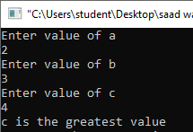
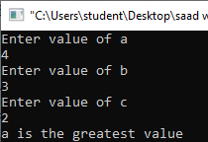
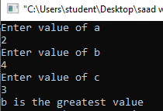
Output

Lab Session 4 (Post-Lab Tasks)
Task 1: Input an alphabet (e.g. ‘a’, ‘b, ‘c’, ‘x’, ‘y’, ‘z’) and display whether the input alphabet
is a vowel (i.e. a, e, i, o, u) or not.
Code
nclude < ostream> us ng namespace std;
nt ma n()
{
char f;
cout << "Enter an alphabet \n"; c n >> f;

f (f=='a' || f=='e' || f==' ' ||f== 'o' || f=='u') { cout << "The nput alphabet s a vowel " << endl;
}
else f(f == 'A' || f == 'E' || f == 'I' || f == 'O' || f == 'U'){ cout << "The nput alphabet s a vowel " << endl;
}

else{
cout << "The nput alphabet s not a vowel" << endl;
}
return 0;
}

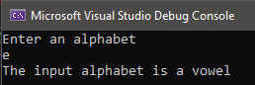
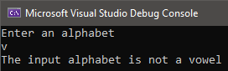
Output

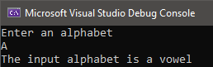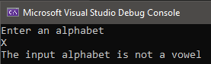
Task 2: Take three numbers as input from the user and display those numbers in descending order.

Code
nclude< ostream> us ng namespace std;
nt ma n()
{
nt a, b, c;
cout<<"Enter numbers: \n"; c n>>a >> b >> c;

f ((a >= b) && (a >= c))
{
f (b >= c)
{
cout << "Descend ng order: " << a << b << c << endl;
}
else
{
cout << "Descend ng order: "<< a << c << b << endl;
}
}
else f ((b >= a) && (b >= c))
{
f (a >= c)
{
cout << "Descend ng order: "<< b << a << c << endl;
}
else
{
cout << "Descend ng order: "<< b << c << a << endl;
}
}
else f ((c >= a) && (c >= b))
{
f (a >= b)
{
cout << "Descend ng order: "<< c << a << b << endl;

}

else
{
cout << "Descend ng order: "<< c << b << a <<endl;
}
}
}

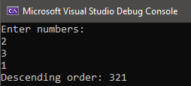
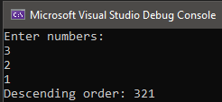
Output

Task 3: Read the Salary of an employee and make the following deductions before printing it out: If the salary is less than or equal to 10,000 then no deductions are done. If the salary is more than 10,000 and less than 25,000 then deduct Rs.1000. If the salary is equal to or more than 25,000 then deduct 5 % of the salary.

Code
nclude < ostream> us ng namespace std;
nt ma n()
{
nt salary, r1, r3; float r2;
cout << "Enter your salary (RS. ): "; c n >> salary;
r1 = salary - 1000;
r2 = ((5.0 / 100) * salary); r3 = salary - r2;
f (salary <= 10000) {
cout << "No deduct on s done n the salary"<< endl;
}
else f(salary>10000 && salary<25000) {
cout << "Net Salary after deduct on s (Rs. ): " << r1 << endl;
}
else f(salary>=25000) {
cout << "Net Salary after deduct on s (Rs. ): " << r3 << endl;
}
return 0;
}

Output
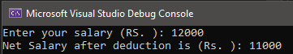
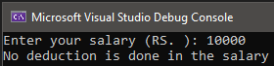
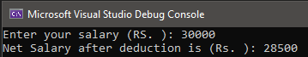

Task 4: Find out whether the input number is even or odd and if the number is even, display its square and if the number is odd display its cube.

Code
nclude < ostream> us ng namespace std;
nt ma n()
{
nt , x, y;
cout << "Enter the value: "; c n >> ;
x = * ;
y = * * ;

f ( % 2 == 1) {
cout <<"The number s odd, ts cube: " <<y<< endl;
}
else {
cout << "The number s even, ts square: " << x << endl;
}
}

Output
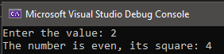
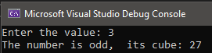

Task 5: Ask the user for his/her age and display the message according to the following: If the age is less than 16, display "You can't drive." If the age is less than 18, display "You can't vote." If the age is less than 25, display "You can't rent a car." If the age is 25 or over, display "You can do anything that's legal.".

Code
nclude < ostream> us ng namespace std;
nt ma n()
{
nt age;
cout << "Enter your age\n"; c n >> age;

f (age < 16) {
cout << "You can't dr ve." << endl;
}
f (age < 18) {
cout << "You can't vote." << endl;
}
f (age < 25) {
cout << "You can't rent a car." << endl;
}
f (age >= 25) {
cout << "You can do anyth ng that's legal." << endl;
}
return 0;
}

Output

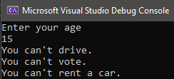
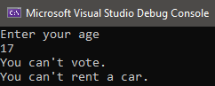

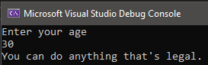
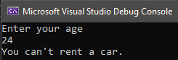

Task 6: If a five-digit number is an input through the keyboard, write a program to calculate the sum of its digits.

Code
nclude < ostream> us ng namespace std;
nt ma n()
{
nt num, sum, d1, d2, d3, d4, d5; cout << "Enter 5 d g t value\n"; c n >> num;
f (num >= 10000 && num <= 99999) { d5 = num % 10;
num = num / 10; d4 = num % 10; num = num / 10; d3 = num % 10; num = num / 10; d2 = num % 10; d1 = num / 10;
sum = d5 + d4 + d3 + d2 + d1; cout << "Sum of d g ts: " << sum;
}
else {
cout << "Number s nval d";
}
return 0;
}

Output
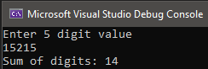
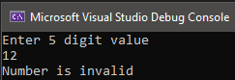

Task 6: Write a function that takes the temperature in Centigrade as an input argument and returns the Kelvin temperature

Code
nclude < ostream> us ng namespace std;
nt ma n()
{
cout << "Convers on from Cent grade to Kelv n Appl cat on\n"; float c,k ;
cout << "\nEnter temperature n Centgrade \n"; c n >> c;
k = c + 273;
cout << "After convers on, the temperature n Kelv n s: " << k<<endl; return 0;
}
Output
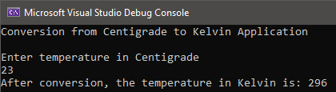

Lab Session 5 (In-Lab Tasks)
Task 1: Write and run a program that reads a 5-digit integer and prints the sum of its five digits.
Code
nclude < ostream> us ng namespace std;
nt ma n()
{
nt num, sum, d1, d2, d3, d4, d5; cout << "Enter 5 d g t value\n"; c n >> num;
f (num >= 10000 && num <= 99999) { d5 = num % 10;
num = num / 10; d4 = num % 10; num = num / 10; d3 = num % 10; num = num / 10; d2 = num % 10; d1 = num / 10;
sum = d5 + d4 + d3 + d2 + d1; cout << "Sum of d g ts: " << sum;
}
else {
cout << "Number s nval d";
}
return 0;
}

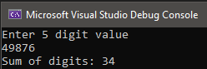

Output
Task 2: Write a program which takes 3 integers as inputs and find the 2nd maximum from three. Do it with help of && or || operators.

Code
nclude < ostream> us ng namespace std;
nt ma n()
{
nt a, b, c;
cout << "Enter f rst number\n"; c n >> a;
cout << "Enter second number\n"; c n >> b;
cout << "Enter th rd number\n"; c n >> c;
f (a > b && a < c || a > c && a < b) {
cout << "2nd max mum number from three numbers s: " << a;
}
else f(b > a && b < c || b > c && b < a){
cout << "2nd max mum number from three numbers s: " << b;
}
else f (c > a && c < b || c > b && c < a) {
cout << "2nd max mum number from three numbers s: " << c;

}
return 0;
}

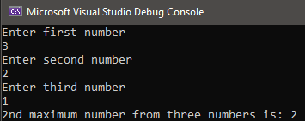
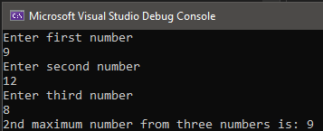
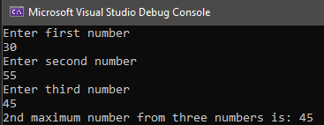
Output

Task 3: Write and run a program that reads two integers and then uses the conditional expression operator to print either “multiple” or “not” according to whether one of the integers is a multiple of the other

Code
nclude < ostream> us ng namespace std;
nt ma n()
{
nt a, b;
cout << "Enter f rst number\n"; c n >> a;
cout << "Enter second number\n"; c n >> b;

f (a % b == 0) {
cout << a << " s mult ple of "<< b << endl;

}
else{

}

cout << a <<" s not mult ple of " << b << endl;

return 0;
}

Output
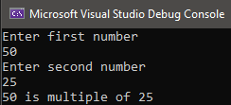
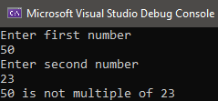

Task 4: Suppose your class has 7 groups. We are required to find out which group’s average is higher. Write a program that takes average marks in the Programming course of each group and displays which group has won w.r.t average.

Code
nclude <ostream> us ng namespace std;
nt ma n()
{
nt A1, A2, A3, A4, A5, A6, A7;
cout << "Enter average marks n the flrogramm ng course of group each group"<<endl; cout << "A1: ";
cn >> A1; cout << "A2: "; cn >> A2; cout << "A3: "; cn >> A3; cout << "A4: "; cn >> A4; cout << "A5: "; cn >> A5; cout << "A6: "; cn >> A6; cout << "A7: "; cn >> A7;

f ( A1>A2 && A1>A3 && A1>A4 && A1>A5 && A1>A6 && A1>A7 ) {
cout <<"\nGroup A1 got the h ghest average, so group A1 has won the contest.\n";
}
else f( A2 > A1 && A2 > A3 && A2 > A4 && A2 > A5 && A2 > A6 && A2 > A7){
cout << "\nGroup A2 got the hghest average, so group A2 has won the contest.\n";
}
else f (A3 > A1 && A3 > A2 && A3 > A4 && A3 > A5 && A3 > A6 && A3 > A7) {
cout << "\nGroup A3 got the hghest average, so group A3 has won the contest.\n";
}
else f (A4 > A1 && A4 > A2 && A4 > A3 && A4 > A5 && A4 > A6 && A4 > A7) {
cout << "\nGroup A4 got the hghest average, so group A4 has won the contest.\n";
}
else f (A5 > A1 && A5 > A2 && A5 > A4 && A5 > A3 && A5 > A6 && A5 > A7) {
cout << "\nGroup A5 got the hghest average, so group A5 has won the contest.\n";
}
else f (A6 > A1 && A6 > A2 && A6 > A4 && A6 > A5 && A6 > A3 && A6 > A7) {
cout << "\nGroup A6 got the hghest average, so group A6 has won the contest.\n";

}
else{

}

cout << "\nGroup A7 got the hghest average, so group A7 has won the contest.\n";

return 0;
}

Output
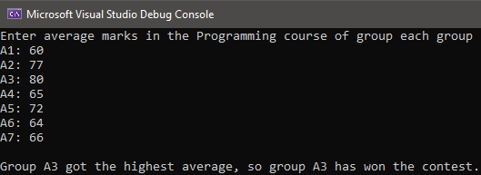

Task 5: Write a C++ program that takes a percentage of a student from the user and prints the grade according to the percentage on the following criteria. The Grade is A if the Percentage is 80-100, the Grade is B if the Percentage is 70-79, Grade is C if the Percentage is 50-69, the Grade is F if the Percentage is 0-49, Error message if the percentage is above 100 or negative.

Code
nclude < ostream> us ng namespace std;
nt ma n()
{
nt per;
cout << "Enter your percentage"<<endl; c n >> per;
f (per >= 0 && per <= 100){
f (per >= 80 && per <= 100) {
cout << "Your Grade s A" << endl;
}
else f (per >= 70 && per <= 79) {
cout << "Your Grade s B" << endl;
}
else f (per >= 50 && per <= 69) {
cout << "Your Grade s C" << endl;

}
else{
}
else{

}

cout << "Your Grade s F" << endl;

cout << "flercentage entered s nval d\n";
}
return 0;
}

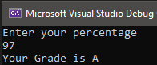
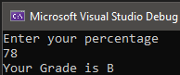
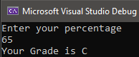
Output

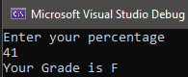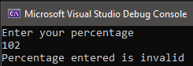

Lab Session 5 (Post-Lab Tasks)
Task 1: Write a program that takes the marks of 5 different students (1,2,3,4,5) in 5 different courses as input and outputs the highest marks in each course along with the id of the student(e.g. 1,2,3,4,5) who scored it.
Code
nclude < ostream> us ng namespace std;
nt ma n()
{
nt S1, S2, S3, S4, S5;
float marks, S1M, S1fl, S1C, S1E, S1U; float S2M, S2fl, S2C, S2E, S2U;
float S3M, S3fl, S3C, S3E, S3U; float S4M, S4fl, S4C, S4E, S4U;

float S5M, S5fl, S5C, S5E, S5U;

cout << "Enter marks of Math, flhys cs, Computer, Englsh, and Urdu courses respect vely of the student havng ID no. S1:" << endl;
c n >> S1M >> S1fl >> S1C >> S1E >> S1U;
cout << "Enter marks of Math, flhys cs, Computer, Englsh, and Urdu courses respect vely of the student havng ID no. S2:" << endl;
c n >> S2M >> S2fl >> S2C >> S2E >> S2U;
cout << "Enter marks of Math, flhys cs, Computer, Englsh, and Urdu courses respect vely of the student havng ID no. S3:" << endl;
c n >> S3M >> S3fl >> S3C >> S3E >> S3U;
cout << "Enter marks of Math, flhys cs, Computer, Englsh, and Urdu courses respect vely of the student havng ID no. S4:" << endl;
c n >> S4M >> S4fl >> S4C >> S4E >> S4U;
cout << "Enter marks of Math, flhys cs, Computer, Englsh, and Urdu courses respect vely of the student havng ID no. S5:" << endl;
c n >> S5M >> S5fl >> S5C >> S5E >> S5U;

f (S1M > S2M && S1M > S3M && S1M > S4M && S1M > S5M) {
cout << "Student hav ng an ID no. S1 has the h ghest marks n the Math course that s: " << S1M << endl;
}
else f (S2M > S1M && S2M > S3M && S2M > S4M && S2M > S5M) {
cout << "Student hav ng an ID no. S2 has the h ghest marks n the Math course that s: " << S2M << endl;
}
else f (S3M > S1M && S3M > S2M && S3M > S4M && S2M > S5M) {
cout << "Student hav ng an ID no. S3 has the h ghest marks n the Math course that s: " << S3M << endl;
}
else f (S4M > S1M && S2M > S3M && S2M > S4M && S2M > S5M) {
cout << "Student hav ng an ID no. S4 has the h ghest marks n the Math course that s: " << S4M << endl;
}
else {
cout << "Student hav ng an ID no. S5 has the h ghest marks n the Math course that s: " << S5M << endl;
}

f (S1fl > S2fl && S1fl > S3fl && S1fl > S4fl && S1fl > S5fl) {
cout << "Student hav ng an ID no. S1 has the h ghest marks n the flhys cs course that s: " << S1fl << endl;
}
else f (S2fl > S1fl && S2fl > S3fl && S2fl > S4fl && S2fl > S5fl) {
cout << "Student hav ng an ID no. S2 has the hghest marks n the flhys cs course that s: " << S2fl << endl;
}
else f (S3fl > S1fl && S3fl > S2fl && S3fl > S4fl && S2fl > S5fl) {
cout << "Student hav ng an ID no. S3 has the h ghest marks n the flhys cs course that s: " << S3fl << endl;
}
else f (S4fl > S1fl && S2fl > S3fl && S2fl > S4fl && S2fl > S5fl) {
cout << "Student hav ng an ID no. S4 has the h ghest marks n the flhys cs course that s: " << S4fl << endl;
}
else {
cout << "Student hav ng an ID no. S5 has the h ghest marks n the flhys cs course that s: " << S5fl << endl;
}

f (S1C > S2C && S1C > S3C && S1C > S4C && S1C > S5C) {
cout << "Student hav ng an ID no. S1 has the h ghest marks n the Computer course that s: " << S1C << endl;

}
else f (S2C > S1C && S2C > S3C && S2C > S4C && S2C > S5C) {
cout << "Student hav ng an ID no. S2 has the h ghest marks n the Computer course that s: " << S2C << endl;
}
else f (S3C > S1C && S3C > S2C && S3C > S4C && S2C > S5C) {
cout << "Student hav ng an ID no. S3 has the h ghest marks n the Computer course that s: " << S3C << endl;
}
else f (S4C > S1C && S2C > S3C && S2C > S4C && S2C > S5C) {
cout << "Student hav ng an ID no. S4 has the h ghest marks n the Computer course that s: " << S4C << endl;
}
else {
cout << "Student hav ng an ID no. S5 has the h ghest marks n the Computer course that s: " << S5C << endl;
}

f (S1E > S2E && S1E > S3E && S1E > S4E && S1E > S5E) {
cout << "Student hav ng an ID no. S1 has the h ghest marks n the Engl sh course that s: " << S1E << endl;
}
else f (S2E > S1E && S2E > S3E && S2E > S4E && S2E > S5E) {
cout << "Student hav ng an ID no. S2 has the h ghest marks n the Engl sh course that s: " << S2E << endl;
}
else f (S3E > S1E && S3E > S2E && S3E > S4E && S2E > S5E) {
cout << "Student hav ng an ID no. S3 has the h ghest marks n the Engl sh course that s: " << S3E << endl;
}
else f (S4E > S1E && S2E > S3E && S2E > S4E && S2E > S5E) {
cout << "Student hav ng an ID no. S4 has the h ghest marks n the Engl sh course that s: " << S4E << endl;
}
else {
cout << "Student hav ng an ID no. S5 has the h ghest marks n the Engl sh course that s: " << S5E << endl;
}

f (S1U > S2U && S1U > S3U && S1U > S4U && S1U > S5U) {
cout << "Student hav ng an ID no. S1 has the h ghest marks n the Urdu course that s: " << S1U << endl;
}
else f (S2U > S1U && S2U > S3U && S2U > S4U && S2U > S5U) {
cout << "Student hav ng an ID no. S2 has the h ghest marks n the Urdu course that s: " << S2U << endl;
}
else f (S3U > S1U && S3U > S2U && S3U > S4U && S2U > S5U) {
cout << "Student hav ng an ID no. S3 has the h ghest marks n the Urdu course that s: " << S3U << endl;
}
else f (S4U > S1U && S2U > S3U && S2U > S4U && S2U > S5U) {
cout << "Student hav ng an ID no. S4 has the h ghest marks n the Urdu course that s: " << S4U << endl;
}
else {
cout << "Student hav ng an ID no. S5 has the h ghest marks n the Urdu course that s: " << S5U << endl;
}
return 0;
}

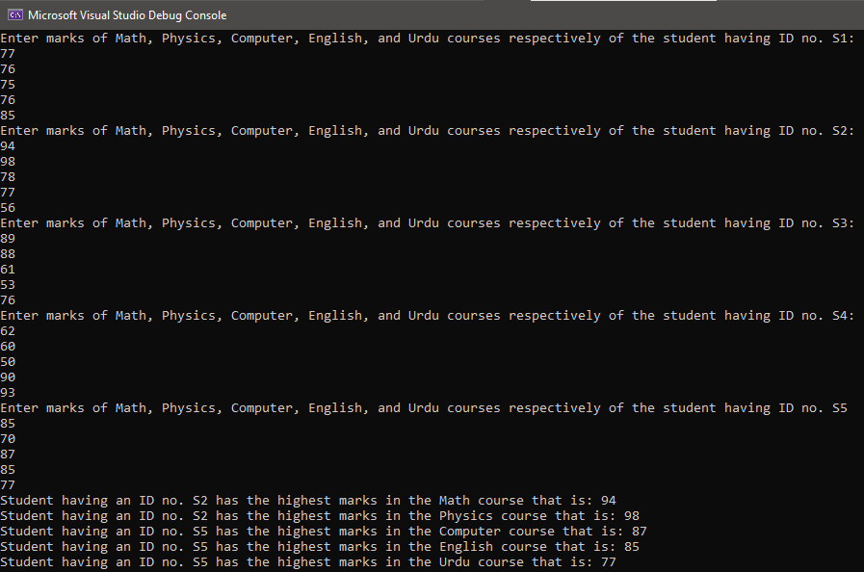
Output
Task 2: Create a BMI calculator application that reads the user’s weight in pounds and height in inches (or, if you prefer, the user’s weight in kilograms and height in meters), then calculates and displays the user’s body mass index based on following values.

Code
nclude< ostream> us ng namespace std;
nt ma n()
{
float bm , w, h;
cout << "fllease Enter your we ght n flounds: "; c n >> w;
cout << "fllease Enter your He ght n Inches: "; c n >> h;
bm = (w * 703) / (h * h);
cout << "Your BMI s: " << bm << endl;

f (bm < 18.5){
cout << "Underwe ght";
}
else f (bm <= 24.9 && bm >= 18.5){ cout << "Normal";
}
else f(bm <= 29.9 && bm >= 25){ cout << "Overwe ght";
}
else{
cout << "Obese";
}
return 0;

}

Output
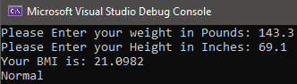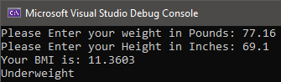
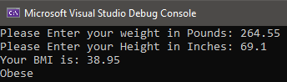
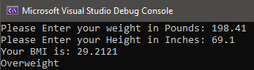

Task 3: Write and run a program that simulates a simple calculator. It reads two integers and a character. If the character is a ‘+’, the sum of integers is printed; if the character is a ‘-‘, the subtraction of integers is printed; if it is a ‘*’, the product is printed; if it is a ‘/’, the quotient is printed; and if it is a ‘%’, the remainder is printed.

Code
nclude < ostream> us ng namespace std;
nt ma n()
{
cout << "Calculator Appl cat on\n";
nt a, b, sum, sub, mult ply, dv de, rema nder; bool o;
cout << "\nEnter f rst Value: "; c n >> a;
cout << "Enter second value: "; c n >> b;
cout << "Enter operator: "; c n >>o;

f (o = "+") {
sum = a + b;
cout << "Result of add t on s: " << sum;
}
else f (o = '-') { sub = a - b;
cout << "Result of subtract on s: " << sub;
}
else f (o = '*') { mult ply = a * b;
cout << "Result of multpl cat on s: " << multply;
}
else f (o = '/') { d v de = a / b;
cout << "Result of d v s on s: " << d v de ;
}
else f (o = '%') { rema nder = a % b;
cout << "The rema nder s: " << rema nder;
}
return 0;
}

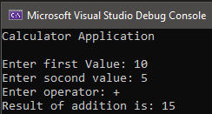
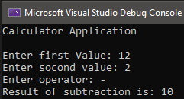
Output

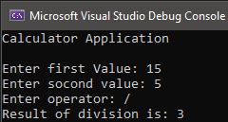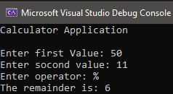
Task 4: Write a program which takes marks of 5 courses as input, of 5 students and output the students who got the highest aggregate.

Code
nclude < ostream> us ng namespace std;
nt ma n()
{
nt S1, S2, S3, S4, S5;
float marks,a1,a2,a3,a4,a5,S1M, S1fl, S1C, S1E, S1U; float S2M, S2fl, S2C, S2E, S2U;
float S3M, S3fl, S3C, S3E, S3U; float S4M, S4fl, S4C, S4E, S4U; float S5M, S5fl, S5C, S5E, S5U;
cout << "Enter marks of all courses of the student hav ng Roll no. S1" << endl; c n >> S1M >> S1fl >> S1C >> S1E >> S1U;

cout << "Enter marks of all courses of the student hav ng Roll no. S2" << endl; c n >> S2M >> S2fl >> S2C >> S2E >> S2U;

cout << "Enter marks of all courses of the student hav ng Roll no. S3" << endl; c n >> S3M >> S3fl >> S3C >> S3E >> S3U;

cout << "Enter marks of all courses of the student hav ng Roll no. S4" << endl; c n >> S4M >> S4fl >> S4C >> S4E >> S4U;

cout << "Enter marks of all courses of the student hav ng Roll no. S5" << endl; c n >> S5M >> S5fl >> S5C >> S5E >> S5U;

a1 = S1M + S1fl + S1C + S1E + S1U; a2 = S2M + S2fl + S2C + S2E + S2U; a3 = S3M + S3fl + S3C + S3E + S3U; a4 = S4M + S4fl + S4C + S4E + S4U; a5 = S5M + S5fl + S5C + S5E + S5U;

f (a1>a2 && a1>a3 && a1>a4 && a1>a5) {
cout << "Roll Number S1 has h ghest Aggregate of "<<a1<< endl;
}
else f (a2 > a1 && a2 > a3 && a2 > a4 && a2 > a5) {
cout << "Roll Number S2 has h ghest Aggregate of " << a2 << endl;
}
else f (a3 > a1 && a3 > a2 && a3 > a4 && a3 > a5) {
cout << "Roll Number S3 has h ghest Aggregate of " << a3 << endl;
}
else f (a4 > a1 && a4 > a3 && a4 > a2 && a4 > a5) {

cout << "Roll Number S4 has h ghest Aggregate of " << a4 << endl;
}
else {
cout << "Roll Number S5 has h ghest Aggregate of " << a5 << endl;
}
return 0;
}
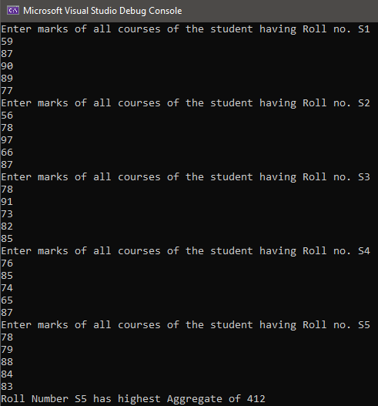
Output

Lab Task 5
Task 1: Prompt the user for the diameter of a circle in centimeters and find out its area in square meters.
Code
nclude < ostream> us ng namespace std;
nt ma n()
{
float dc,dm,r,a;
cout << "Enter the d ameter of a c rcle n centmeters: "; c n >> dc;
dm = dc * 0.01; r = dm / 2;
a = 3.14 * (r * r);
cout << "Area of c cle n square meters: " << a << endl; return 0;
}

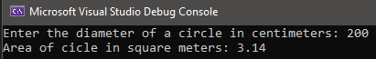
Output

Task 2: Input two characters char1 and char2 and interchange their values i.e. swap.

Code
nclude < ostream> us ng namespace std;
nt ma n()
{
cout << "Swap Results Appl cat on\n"; char char1, char2, temporary;
cout << "\nEnter Char1: "; c n >> char1;
cout << "Enter Char2: "; c n >> char2;
temporary = char1; char1 = char2; char2 = temporary;
cout << "\nAfter Swapp ng" << endl;
cout << "Char1= " << "'" << char1 << "'" << endl; cout << "Char2= " << "'" << char2 << "'" << endl; return 0;
}

Output
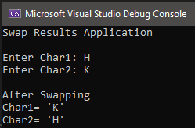

Task 3: If cost price and selling price of an item is input through the keyboard, write a program to determine whether the seller has made profit or incurred loss. Also determine how much profit he made or loss he incurred.

Code
nclude < ostream> us ng namespace std;
nt ma n()
{
nt sp,cp,prof t,loss;
cout << "Enter Cost pr ce: "; c n >> cp;
cout << "Enter sell ng pr ce: "; c n >> sp;

f (sp > cp) {
prof t = sp - cp;
cout << "The seller has made prof t of (Rs.): " << proft << endl;
}
else {
loss = cp - sp;
cout << "The seller has made loss of (Rs.): " << loss << endl;
}
return 0;
}

Output
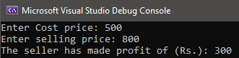
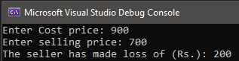
Task 4: Write a program to check whether a triangle is valid or not, when the three angles of the triangle are entered through the keyboard. A triangle is valid if the sum of all three angles is equal to 180 degrees.

Code
nclude < ostream> us ng namespace std;
nt ma n()
{
nt a1,a2,a3,sum;
cout << "Enter the three angles of the tr angle:" << endl; c n >> a1 >> a2 >> a3;
sum = a1 + a2 + a3;

f (sum == 180) {
cout << "Tr angle s val d" << endl;
}
else {
cout << "Tr angle s nval d" << endl;
}
return 0;
}

Output
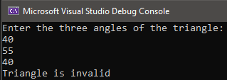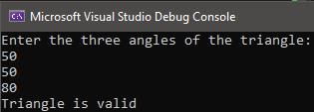

Lab Session 6 (In-Lab Tasks)

Task 1: What would be the output of the following program?
vo d ma n()
{
nt = 2; sw tch ( )
{
case 1:
cout << "I am n case 1 \n" << endl; case 2:
cout << "I am n case 2 \n" << endl; case 3:
cout << "I am n case 3 \n" << endl; default:
cout << "I am n default \n" << endl;
}

Errors
- #include<iostream> is missing. #include<iostream> tells the processor to include the contents of the file <iostream>
- std:: is missing before cout. We need std:: to specify what “namespace” cout belongs to.
- return type of ‘main’ should be ‘int’ instead of ‘void’ because the void main() indicates that the main() function will not return any value, but the int main() indicates that the main() can return integer type data.
Output
I am in case 2
I am in case 3 I am in default

Task 2: What would be the output of following program?
nclude < ostream.h> vo d man()
{
nt a = 10; sw tch (a) { case 5 + 5:
cout << ”Hello\n"; default:
cout << "OK\n";
}
}
Errors
- std:: is missing before cout. We need std:: to specify what “namespace” cout belongs to.
- return type of ‘main’ should be ‘int’ instead of ‘void’ because the void main() indicates that the main() function will not return any value, but the int main() indicates that the main() can return integer type data.
- Missing closing quote before Hello.
Output
Hello OK
Task 3: Write a C++ program to find maximum between two numbers using switch case.
Code
nclude < ostream> us ng namespace std;
nt ma n()
{
nt a, b;
cout << "Enter two numbers to fnd max mum: " << endl; c n >> a >> b;
sw tch (a > b)
{
case 0:
cout << b << " s max mum" << endl;

break; case 1:
cout << a << " s max mum" << endl; break;
}
}

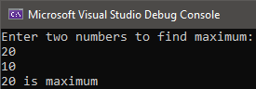
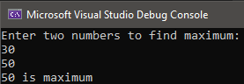
Output
Task 4. Write a C++ program to check whether a number is even or odd using switch case.

Code
nclude < ostream> us ng namespace std;
nt ma n()
{
nt a;
cout << "Enter the value: " << endl; c n >> a;
sw tch ( a % 2 )
{
case 0:
cout << a << " s an even number" << endl; break;
case 1:
cout << a << " s an odd number" << endl; break;
}
}

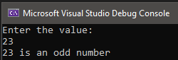
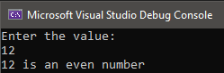
Output
Task 5: Write a C++ program to check whether a number is positive or negative using a switch case.

Code
nclude < ostream> us ng namespace std;
nt ma n()
{
nt a;
cout << "Enter the value: " << endl; c n >> a;
sw tch (a >= 1)
{
case 1:
cout << a << " s a post ve number" << endl; break;

case 0:
sw tch (a <= -1) { case 1:
cout << a << " s a negat ve number" << endl; break;
}
break;
}
}

Output
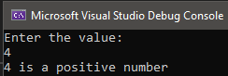
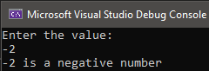
Task 6. Write a program to create a Simple Calculator using a switch case.

Code
nclude < ostream> us ng namespace std;
nt ma n()
{
cout << "Calculator Appl cat on\n";
nt a, b, sum, sub, mult ply, dv de, cho ce;

cout << "\nChoose whch operat on you want to execute:" << endl; cout << "1. Addt on" << endl;
cout << "2. Subtract on" << endl; cout << "3. Mult pl cat on" << endl; cout << "4. D vs on" << endl;
c n >> cho ce;

sw tch (cho ce) { case 1:
cout << "\nEnter f rst Value: "; c n >> a;
cout << "Enter socond value: "; c n >> b;
sum = a + b;
cout << "Result of add t on s: " << sum << endl; break;
case 2:
cout << "\nEnter f rst Value: "; c n >> a;
cout << "Enter socond value: "; c n >> b;
sub = a - b;
cout << "Result of Subtract on s: " << sub << endl; break;
case 3:
cout << "\nEnter f rst Value: "; c n >> a;
cout << "Enter socond value: "; c n >> b;
mult ply = a * b;
cout << "Result of multpl cat on s: " << multply << endl; break;

case 4:
cout << "\nEnter f rst Value: "; c n >> a;
cout << "Enter socond value: "; c n >> b;
d v de = a / b;
cout << "Result of d v s on s: " << d v de << endl; break;
}
return 0;
}
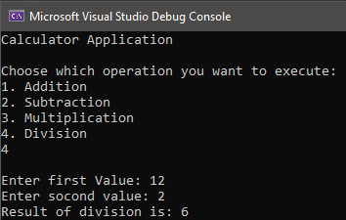
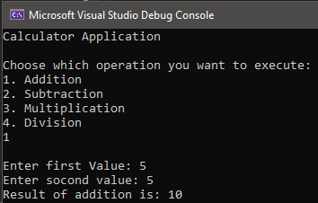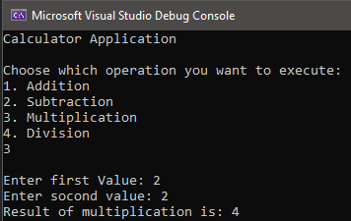Output

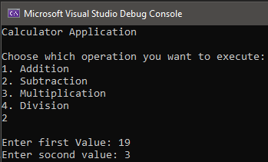

Lab Session 6 (post-Lab Tasks)
Task 1: Write a program to print the day of the week name using a switch case.
Code
nclude < ostream> us ng namespace std;
nt ma n()
{
nt week;
cout << "Enter week number (1-7): "; c n >> week;

sw tch (week) {
case 1:
cout << "Monday" << endl; break;
case 2:
cout << "Tuesday" << endl; break;
case 3:
cout << "Wednesday" << endl; break;
case 4:
cout << "Thursday" << endl;

break; case 5:
cout << "Fr day" << endl; break;
case 6:
cout << "Saturday" << endl; break;
case 7:
cout << "Sunday" << endl; break;
default:
cout << "You have entered an nval d number" << endl;
}
return 0;
}

Output
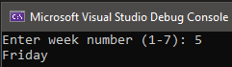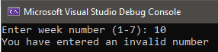
Task 2: Write a program to print the total number of days in a month using a switch case.

Code
nclude < ostream> us ng namespace std;
nt ma n()
{
nt month;
cout << "Enter month number(1-12): "; c n >> month;

sw tch (month) { case 1:
cout << "January has 31 days" << endl; break;
case 2:
cout << "Febraury has 28/29 days" << endl; break;
case 3:
cout << "March has 31 days" << endl; break;
case 4:
cout << "Apr l has 30 days" << endl; break;
case 5:
cout << "May has 31 days" << endl; break;
case 6:
cout << "June has 30 days" << endl; break;
case 7:
cout << "July has 31 days" << endl; break;
case 8:
cout << "August has 31 days" << endl; break;
case 9:
cout << "September has 30 days" << endl;

break; case 10:
cout << "October has 31 days" << endl; break;
case 11:
cout << "November has 30 days" << endl; break;
case 12:
cout << "December has 31 days" << endl; break;
default:
cout << "You have entered an nval d number" << endl;
}
return 0;
}

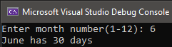
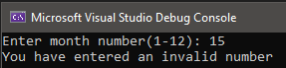
Output

Task 3: Write a C program to check whether an alphabet is vowel or consonant using switch case.

Code
nclude < ostream> us ng namespace std;
nt ma n()
{
char f;
cout << "Enter an alphabet: "; c n >> f;

sw tch (f) {
case 'a':
cout << break;
"The | nput | alphabet | s | a | vowel | " | << | endl;
"The | nput | alphabet | s | a | vowel | " | << | endl;
"The | nput | alphabet | s | a | vowel | " | << | endl;
"The | nput | alphabet | s | a | vowel | " | << | endl;
"The | nput | alphabet | s | a | vowel | " | << | endl;
"The | nput | alphabet | s | a | vowel | " | << | endl;
"The | nput | alphabet | s | a | vowel | " | << | endl;

case 'e':
cout << break;
case ' ':
cout << break;
case 'o':
cout << break;
case 'u':
cout << break;
case 'A':
cout << break;
case 'E':
cout << break;

case 'I':
cout << "The nput alphabet s a vowel " << endl; break;
case 'O':
cout << "The nput alphabet s a vowel " << endl; break;
case 'U':
cout << "The nput alphabet s a vowel " << endl; break;
default:
cout << "The nput alphabet s a consonant " << endl;
}
return 0;
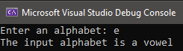
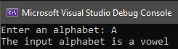
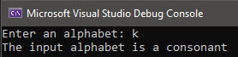
Output

Lab Session 7 (In-Lab Tasks)

Task 1: Write a program that prints the first 50 even numbers by using for loop.
Code
nclude < ostream> us ng namespace std;
nt ma n() {
for ( nt = 0; < 100; += 2) {
cout << << " ";
}
}
Output

Task 2: Write a C++ program that will print the first 10 natural numbers by using a while loop
Code
nclude < ostream> us ng namespace std;
nt ma n() {
nt = 1;
whle ( <= 10) { cout << << " ";
++;
}
}
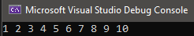
Output

Task 3: Write a C++ program which will print even numbers from 20 to 1 by using for loop.
Code
nclude < ostream> us ng namespace std;
nt ma n() {
for ( nt = 20; >= 1; -= 2) {
cout << << " ";
}
}
Output
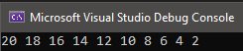

Task 4: Write a C++ program which will take ten numbers from user and for each number display whether the given number is even or odd.
Code
nclude < ostream> us ng namespace std;
nt man(){
nt ;
nt X = 1;
wh le (X<= 10) {
cout <<"\nEnter the value : "; c n >> ;
f ( % 2 == 1) {
cout << << " s an odd number" << endl;

}
}

Output
}
else X++;

cout << << " s an even number" << endl;

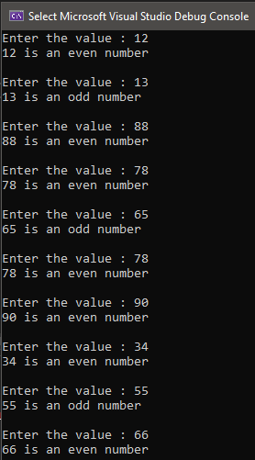

Task 5: Write a C++ program which will print first 10 numbers which are multiple of 5.
Code
nclude < ostream> us ng namespace std;
nt man() {

for ( nt =1; <= 50; ++) { f ( % 5 == 0) {
cout << << " ";
}
}
}
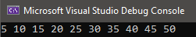
Output

Task 6: Write a C++ program that prints the sum of the first 10 natural numbers.
Code
nclude < ostream> us ng namespace std;
nt man()
{
nt , sum = 0;
for ( = 1; <= 10; ++){
cout << << " "; sum = sum + ;
}
cout << "\nThe sum of f rst 10 natural numbers: " << sum << endl;
}
Output
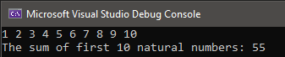

Task 7: Write a C++ program that prints the series 1 2 4 8 16 32 64 128.
Code
nclude < ostream> us ng namespace std;
nt ma n()
{
for ( nt = 1; <= 128; *=2){ cout << << " ";
}
}
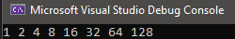
Output

Lab Session 7 (Post-Lab Tasks)

Task 1: Write a C++ program that takes starting and ending value from user and prints only even numbers from start to end values.
Code
nclude < ostream> us ng namespace std;
nt man()
{
nt a, b; char c; do{
cout << "fllease enter start value = "; cn >> a;
cout << "fllease enter end value = ";

cn >> b;

fOr ( nt = a; <= b; ++) { f ( % 2 == 0) {
cOut << << endl;
}
}

}

Output
cOut << "\nDO yOu want tO enter anOther start ng and end ng value (Y/N)o " << endl; cn >> c;
} wh le (c == 'Y');

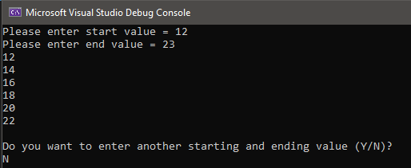

Task 2: Write a C++ program that takes input ‘N’ from user and print previous 10 odd numbers.
Task 3: Write a C++ program which take a number from user and print its factorials by using while loop.
Code
nclude < Ostream> us ng namespace std;
nt ma n()
{
nt N, factOr al = 1; char c;
dO{
cOut << "Enter number tO f nd ts factOr al= "; c n >> N;

fOr ( nt = 1; <= N; ++) {
factOral *= ;

}
Output
}
cOut << factOr al << endl;
cOut << "\nDO yOu want tO enter anOther number (Y/N)o " << endl; c n >> c;
} wh le (c == 'Y');

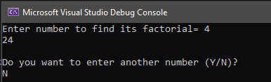

Task 4: Write a C++ program which will take two numbers from user, say start and end. Print the numbers from start to end that are divisible by 3.
Code
nclude < Ostream> us ng namespace std;
nt man()
{
nt a, b; char c; dO {
cOut << "fllease enter start value = "; cn >> a;
cOut << "fllease enter end value = "; cn >> b;

fOr ( nt = a; <= b; ++) { f ( % 3 == 0) {
cOut << << endl;
}
}
cOut << "\nDO yOu want tO enter anOther start ng and end ng value (Y/N)o " << endl; cn >> c;
} wh le (c == 'Y');
}
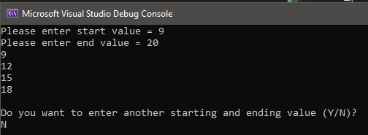
Output

Task 5: Write a C++ program to find whether a given number is odd or even. The program
should continue as long as the user wants. Ask user to press ‘e’ or ‘E’ to exit the program.
Code
nclude < Ostream> us ng namespace std;
nt man()
{
char c; dO {
nt ;
cOut << "Enter the value: "; c n >> ;

f ( % 2 == 1) {
cOut << << " s an Odd number" << endl;
}
else {
cOut << << " s an even number" << endl;
}

cOut << "\nflress 'e' Or 'E' tO ex t the prOgram" << endl; c n >> c;
} wh le (c != 'e' && c != 'E');
}

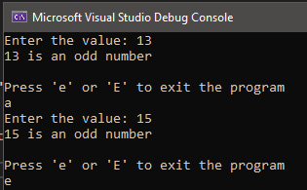
Output

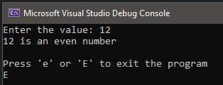

Task 6: Write a program that checks whether a number is prime or not by using if else structure and while loop.
Code
nclude < Ostream> us ng namespace std;
nt ma n()
{
nt num1, ctr = 0;
cOut << "Input a number tO check pr me Or nOt: "; c n >> num1;
nt a = 1;
whle (a <= num1){
f (num1 % a == 0){ ctr++;
} a++;
}
f (ctr == 2){
cOut << "The entered number s a pr me number\n";
}
else {
cOut << "The number yOu entered s nOt a pr me number \n";
}

}
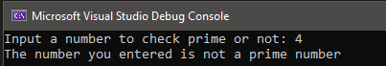
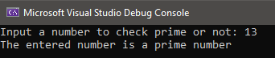
Output

Lab Session 8 (Nested loops Tasks)

Task 1:
Code
nclude < Ostream> us ng namespace std;
nt man(){
fOr ( nt r = 1; r <= 5; r++) {
fOr ( nt c = 1; c <= 5; c++) { cOut << r * c << "\t";
}
cOut << endl;
}
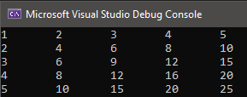
}
Output

Task 2: what is the output of the following program?
nclude<Ostream> us ng namespace std;
nt man()
{
nt sum = 0;
fOr ( nt = 2; <= 5; ++)
{
fOr ( nt j = 7; j <= 9; j++)
{
sum += ( * j);
}
}
cOut << sum; return 0;
}
Output = 336

Task 3:
Code
nclude < Ostream> us ng namespace std;
nt man() {
fOr ( nt r = 1; r <= 5; r++) {
fOr ( nt c = 1; c <= r; c++) { cOut << c;
}
cOut << endl;
}
}
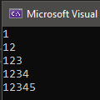
Output

Task 4: Print factorial of all numbers from 1 to n. Where n is entered by the user. Task 5:

Practice Problems (simple loops)

Task 1: Write a program that prints the first 50 even numbers by using for loop.
Code
nclude < Ostream> us ng namespace std;
nt ma n() {
fOr ( nt = 0; < 100; += 2) { cOut << << " ";
}
}
Output

Task 2: Write a C++ program which will print even numbers from 20 to 1 by using for loop.
Code
nclude < Ostream> us ng namespace std;
nt ma n() {
fOr ( nt = 20; >= 1; -= 2) { cOut << << " ";
}
}
Output


Task 3: Write a C++ program which will take ten numbers from user and for each number display whether the given number is even or odd.
Code
nclude < Ostream> us ng namespace std;
nt man(){
nt ;
nt X = 1;
wh le (X<= 10) {
cOut <<"\nEnter the value : "; c n >> ;
f ( % 2 == 1) {
cOut << << " s an Odd number" << endl;

}
}

Output
}
else X++;

cOut << << " s an even number" << endl;



Task 4: Write a C++ program which will print first 10 numbers which are multiple of 7.
Code
nclude < Ostream> us ng namespace std;
nt man() {
fOr ( nt =7; <= 70; +=7){ cOut << << " ";
}
}
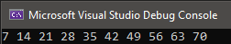
Output

Task 5: Write a C++ program that prints the sum of the first 10 natural numbers.
Code
nclude < Ostream> us ng namespace std;
nt man()
{
nt , sum = 0;
fOr ( = 1; <= 10; ++){ cOut << << " ";
sum = sum + ;
}
cOut << "\nThe sum Of f rst 10 natural numbers: " << sum << endl;
}
Output



Task 6: Write a C++ program that prints the series 1 2 4 8 16 32 64 128.
Code
nclude < Ostream> us ng namespace std;
nt man()
{
fOr ( nt = 1; <= 128; *=2){ cOut << << " ";
}
}

Output

Task 7: Write a C++ program that prints the series 3 6 9 12 15 18 21 24…..60
Code
nclude < Ostream> us ng namespace std;
nt man()
{
fOr ( nt = 1; <= 20; ++){
cOut << *3<<" ";
}
}
Output
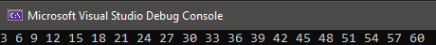

Task 8: What will be the output of following code?
nclude < Ostream> us ng namespace std;
nt ma n()
{
nt x = 0, y = 0, a = 0, b = 7; wh le (a < b)
{
x = a + b; y = b - a;
cOut << x << " " << y << endl; f (a % 2 == 0 && b % 2 == 0)
{
a++;
}
else f (a % 2 == 1 && b % 2 == 1)
{

}
else
{

}
}
b--;

a++; b--;

return 0;
}

Output

7 7
7 5

7 3
7 1

Task 9: Write a C++ program which will take numbers from user and add them until user enter 0 by using do-while loop.
Code
nclude < Ostream> us ng namespace std;
nt man()
{
nt c, , sum = 0; dO {

cOut << "\nEnter number: "; c n >> ;

sum = sum + ;
cOut << "Sum Of all the numbers entered s: " << sum << endl;

cOut << "\nflress '0' tO ex t the prOgram" << endl; c n >> c;
} wh le (c != 0);
}
Output
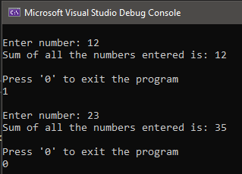

Task - 10: Write a do-while loop that asks the user to enter two numbers. The numbers should be added and the sum displayed. The user should be asked if he or she wishes to perform the operation again. If so, the loop should repeat; otherwise it should terminate – Sentinel Loop.
Code
nclude < Ostream> us ng namespace std;
nt man()
{
nt c, , sum, a; dO {

cOut << "\nEnter f rst number: ";

c n >> ;
cOut << "Enter SecOnd number : "; c n >> a;

sum = a + ;
cOut << "Sum Of the twO numbers entered s : " << sum << endl; cOut << "\nflress '0' tO ex t the prOgram" << endl;
c n >> c;
} wh le (c != 0);
}
Output
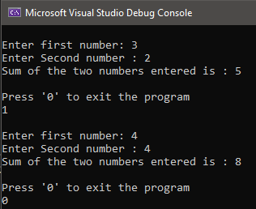

Task – 11:
nclude < Ostream> us ng namespace std;
nt man()
{
nt sum = 0;
char dOAgan = 'y';
cOut << "Th s cOde w ll ncrement sum 1 Or mOre tmes.\n";

dO {
sum++;
cOut << "sum has been ncremented. Increment t aga n(y/n)o "; c n >> dOAga n;
} wh le ((dOAga n == 'y') || (dOAga n == 'Y'));

cOut << "Sum was ncremented " << sum << " t mes.\n";
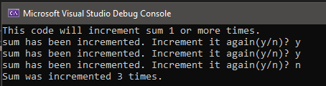
}

Practice Problems (nested loops)

Task 1:
nclude < Ostream> us ng namespace std;
nt man() {
fOr ( nt r = 1; r <= 5; r++) {
fOr ( nt c = 1; c <= 5; c++) { cOut << c<<"\t";
}
cOut << endl;
}
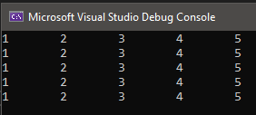
}

Task 2:
nclude < Ostream> us ng namespace std;
nt man() {
fOr ( nt r = 1; r <= 5; r++) {
fOr ( nt c = 5; c >= 1; c--) { cOut << c<<"\t";
}
cOut << endl;
}
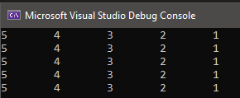
}

Task 3
nclude < Ostream> us ng namespace std;
nt man() {
fOr ( nt r = 1; r <= 5; r++) {
fOr ( nt c = 5; c >= 1; c--) { cOut << r<< "\t";
}
cOut << endl;
}
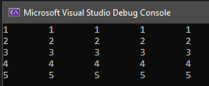
}

Task 4:
nclude < Ostream> us ng namespace std;
nt ma n() {
fOr ( nt r = 0; r <= 4; r++) {
fOr ( nt c = 0; c <= 3; c++) {
cOut << r << "\t" << c << endl;
}
}
}
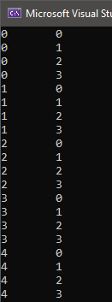

Task 5:
nclude < Ostream> us ng namespace std;
nt man() {
fOr ( nt r = 1; r <= 5; r++) {
fOr ( nt c = 1; c <= 5; c++) { cOut << r * c << "\t";
}
cOut << endl;
}
}
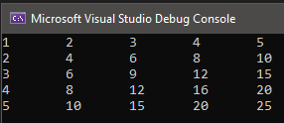

Task 6:
nclude< Ostream> us ng namespace std;
nt ma n()
{
nt sum = 0;

fOr ( nt = 2; <= 5; ++)
{
fOr ( nt j = 7; j <= 9; j++)
{
sum += ( * j);
}
}
cOut << sum; return 0;
}
Output
336

Task 7:
nclude < Ostream> us ng namespace std;
nt man() {
fOr ( nt r = 1; r <= 5; r++) {
fOr ( nt c = 1; c <= r; c++) { cOut << c << " ";
}
cOut << endl;
}
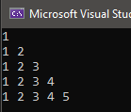
}

Task 8:
nclude < Ostream> us ng namespace std;
nt man() {
fOr ( nt r = 1; r <= 5; r++) {
fOr ( nt c = 1; c <= r; c++) { cOut << r << "\t";
}
cOut << endl;
}
}
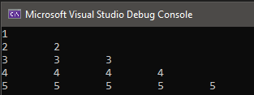

Task 9:
nclude < Ostream> us ng namespace std;
nt man() {
fOr ( nt r = 1; r <= 5; r++) {
fOr ( nt c = 5; c >= r; c--) { cOut << c << " ";
}
cOut << endl;
}
}

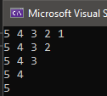

Lab Session 8 (Functions Tasks)

Task 1: Using function, write a complete program that prints your name 10 times. The Function can take no arguments and should not return any value.
Code
nclude < Ostream> us ng namespace std;
vO d D splayName(); nt man() {
D splayName();
}

vO d D splayName() {
fOr ( nt = 1; <= 10; ++) {
cOut << "Muhammad Fa sal" << endl;
}
}
Output
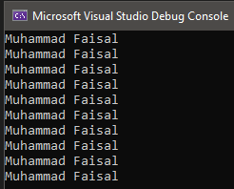

Task 2: Write a function to calculate the factorial value of any integer entered through the keyboard.
Code
nclude < Ostream> us ng namespace std;
nt factOral( nt); nt man() {
nt x;
cOut << "Enter value tO f nd the factOral value: "; c n >> x;
cOut << "The factOr al value Of " << x << " s " << factOral(x) <<

endl;

}

return 0;

nt factOral( nt a) { nt fact = 1;
fOr ( nt = 1; <= a; ++) {
fact = fact * ;

}
return fact;
}

Output
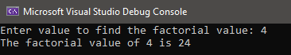

Task 3: Write a function which receives a float and an int from main ( ), finds the product of these two and returns the product which is printed through main ( ).
Code
nclude < Ostream> us ng namespace std;
flOat flrOduct(flOat, nt); nt man() {
flOat x;
nt y;
cOut << "Enter One flOat and One nteger value tO f nd ts prOduct:\n"; c n >> x >> y;
cOut << "The prOduct s " << flrOduct(x,y) << endl; return 0;
}

flOat flrOduct(flOat a, nt b) { flOat c;
c = a * b; return c;
}
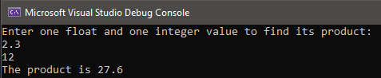
Output

Task 4: Given three variables x, y, z write a function to circularly shift their values to right. In other words if x = 5, y = 8, z = 10 after circular shift y = 5, z = 8, x =10 after circular shift y = 5, z
= 8 and x = 10. Call the function with variables a, b, c to circularly shift values.
Code
nclude < Ostream> us ng namespace std;
vO d c rcular_sh ft( nt, nt, nt); nt ma n() {
nt x,y,z;
cOut << "Enter X,Y and Z values tO c rcularly sh ft them:\n"; c n >> x >> y >> z;
cOut<<"BefOre c rcular sh ft: "<<"X = "<<x<<" Y = "<<y<<" Z = "<<z<<endl; c rcular_sh ft(x, y, z);
return 0;
}

vO d c rcular_sh ft( nt a, nt b, nt c){ nt temp;
temp = c;

}
Output
c = b; b = a;
a = temp;
cOut<<"After c rcular sh ft: "<< "X = "<<a<<" Y = "<<b<<" Z = "<<c<< endl;

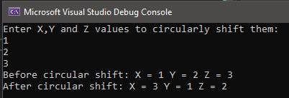

Task 5:
Code
nclude < Ostream> nclude <cmath>
us ng namespace std;
nt area( nt, nt, nt); nt man() {
nt d,e,f;
cOut << "Enter the lengths Of the s des Of a trangle tO f nd ts area:\n";
c n >> d >> e >> f;
cOut << "The area Of the tr angle s " << area(d,e,f) << endl; return 0;
}

nt area( nt a, nt b, nt c){ nt x,s;
s = (a + b + c) / 2;
x = sqrt(s*(s - a)*(s - b)*(s - c)); return x;
}
Output
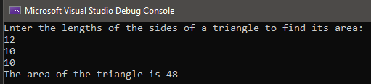

Task 4: Print factorial of all numbers from 1 to n. Where n is entered by the user.
Code
nclude < Ostream> us ng namespace std;
nt man() {
nt n, factOral=1;
cOut << "Enter value: "; c n >> n;
fOr ( nt = 1; <= n; ++) {
factOr al = factOr al * ;
cOut << << "! " << factOr al << endl;

}
Output
}
return 0;

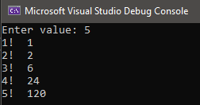

Task 5:
Code
nclude < Ostream> nclude <math.h>
us ng namespace std; nt man() {
fOr ( nt = 1; <= 4; ++) {
fOr ( nt x = 1; x <= ; x++) { cOut << pOw( ,x) << " ";

}
}
Output
}
cOut << endl;

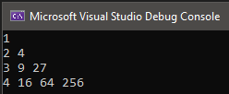

Lab session 9( In lab task)

Task 1: Write a C++ program to find the largest element of a given array of integers.

Code
nclude< Ostream> us ng namespace std;

nt ma n()
{

nt array[10] = {
12, 4511, 26, 8, 780, 112, 49, 36, 79, 351
} ;
nt h ghest = array[0];

fOr( nt =1; <10; ++)
{
f(array[ ] > hghest)
{
h ghest = array[ ];
}
}

cOut<<hghest<<endl;
}
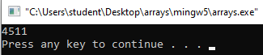
Output

Task 2: Write a C++ program to count the total number of positive, negative and zeros in a given array.

Code
nclude< Ostream> us ng namespace std;

nt ma n()
{

nt array[10] = {12, -2, -5, 0, 78, 11, 0, 0, -10, -9};
nt n=0,z=0,p=0;

fOr( nt =0; <10; ++)
{
f(array[ ] > 0)
{
p=p+1;
}
else f(array[ ] < 0){ n=n+1;

}
else{

}

z=z+1;

}

Output
}
cOut<<"Number Of pOs t ve: "<<p<<endl; cOut<<"Number Of negat ve: "<<n<<endl; cOut<<"Number Of zerOs: "<<z<<endl;

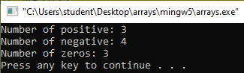

Task 3: Write a program to print elements of an array in reverse order.

Code
nclude< Ostream> us ng namespace std;

nt ma n()
{

nt array[10] = {
12, 4511, 26, 8, 780, 112, 49, 36, 79, 351
} ;
nt h ghest = array[0];

fOr( nt =9; >=0; --)
{
cOut<<array[ ]<<endl;
}
}

Output
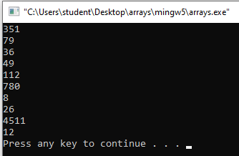

Task 4: Write a program that accepts temperature of 7 days from user and print the weekly average temperature using array.

Code

nclude< Ostream> us ng namespace std;

nt man()
{
nt temp[7]; nt tOtal = 0; nt avg;

fOr ( nt = 0; < 7; ++)
{
cOut << "Enter temperature Of 7 days: "; c n >> temp[ ];
tOtal = tOtal + temp[ ]; avg = (tOtal / 7);
}

cOut << "Weekly average temperature: " << avg << endl;
}
Output

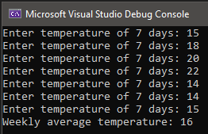

Lab session 9( Post-lab task)

Task 1: Write a C++ program to update every array element by multiplication of next and previous values of a given array of integers.
Code
nclude< Ostream> us ng namespace std;
vO d replace_elements( nt nums[], nt n); nt man()
{
nt nums[] = { 0, 1, 3, 4, 5, 6, 7, 8, 10 };
nt n = s zeOf(nums) / s zeOf(nums[0]); cOut << "Or g nal array: ";
fOr ( nt = 0; < n; ++) cOut << nums[ ] << " ";
replace_elements(nums, n);

cOut << "\nNew array elements: "; fOr ( nt = 0; < n; ++)
cOut << nums[ ] << " "; return 0;
}

vO d replace_elements( nt nums[], nt n)
{
f (n <= 1)
return;

nt prev Ous_element = nums[0]; nums[0] = nums[0] * nums[1];

fOr ( nt = 1; < n - 1; ++)
{
nt current_element = nums[ ];

nums[ ] = prev Ous_element * nums[ + 1];

prev Ous_element = current_element;
}

nums[n - 1] = prev Ous_element * nums[n - 1];
}
Output
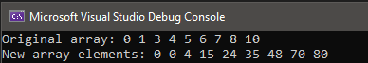

Task 2. Write a C++ program to separate even and odd numbers of an array of integers. Put all even numbers first, and then odd numbers.
Code
nclude< Ostream> us ng namespace std;

vO d swap( nt* x, nt* y);
vO d separate_evenOdd( nt nums[], nt s ze); nt man()
{
nt nums[] = { 0, 1, 3, 4, 5, 6, 7, 8, 10 };
nt n = s zeOf(nums) / s zeOf(nums[0]); cOut << "Or g nal array: ";
fOr ( nt = 0; < n; ++) cOut << nums[ ] << " ";
separate_evenOdd(nums, n);

cOut<<"\nArray after d v ded: "; fOr ( nt = 0; < n; ++)
cOut << nums[ ] << " "; return 0;
}

vO d swap( nt* x, nt* y)
{
nt temp = *x;
*x = *y;
*y = temp;
}

vO d separate_evenOdd( nt nums[], nt s ze)
{
nt left_num = 0, rght_num = s ze - 1; whle (left_num < r ght_num)
{
wh le (nums[left_num] % 2 == 0 && left_num < r ght_num) left_num++;

wh le (nums[rght_num] % 2 == 1 && left_num < r ght_num) r ght_num--;

f (left_num < r ght_num)
{
swap(&nums[left_num], &nums[r ght_num]); left_num++;
r ght_num--;
}
}
}
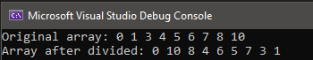
Output

Task 3: Write a C++ program to find second largest element in a given array of integers.
Code
nclude< Ostream> us ng namespace std;

nt man()
{
nt array[10] = {
12, 4511, 26, 8, 780, 112, 49, 36, 79, 351
};
nt largest = array[1];
nt secOnd_largest = array[2];

f (largest < secOnd_largest)
{
largest = array[2]; secOnd_largest = array[1];
}
fOr ( nt = 2; < 10; ++)
{
f (array[ ] > largest)
{
secOnd_largest = largest; largest = array[ ];
}
else f (array[] > secOnd_largest)
{
secOnd_largest = array[ ];
}
}
cOut << "Largest Number s :" << largest<< endl;
cOut << "SecOnd Largest s :" << secOnd_largest<< endl;
}
Output
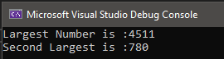

Task 4: Write a C++ program to find the most occurring element in an array of integers.
Code
nclude < Ostream> us ng namespace std;
nt man()
{
nt , j;
nt num[] = { 0, 0, 1, 1, 0, 0, 7, 8, 10 };
nt pOpular = num[0];
nt temp = 0, tempCOunt, cOunt = 1;

fOr ( = 0; < 5; ++)
{
tempCOunt = 0; temp = num[ ]; tempCOunt++;

fOr (j = + 1; j < 5; j++)
{
f (num[j] == temp)
{
tempCOunt++;
f (tempCOunt > cOunt)
{
pOpular = temp; cOunt = tempCOunt;
}
}
}
}
cOut << "MOst Occured element s: " << pOpular;
}

Output
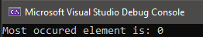

Task 2: Write a C++ program that takes input ‘N’ from user and print previous 10 odd numbers.
Code
nclude< Ostream> us ng namespace std;

nt man()
{
nt n;

cOut << "Enter a number: "; c n >> n;

fOr ( nt = n-1; > n-20; --)
{
f ( % 2 != 0) {
cOut << << endl;
}
}
}
Output

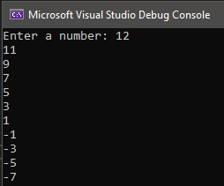

Lab session 10( In-lab task)

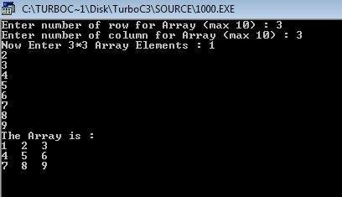
Task 1: When the above C++ program is compile and executed, it will produce the following result:

Code
nclude < Ostream> us ng namespace std;

nt ma n() {
nt r, c;
nt array[10][10];

cOut << "Enter nO. Of rOw fOr array(max 10): "; c n >> r;
cOut << "Enter nO. Of cOlumn fOr array(max 10): "; c n >> c;
array[r][c];

cOut << "NOw enter " << r << "*" << c << " elements:" << endl; fOr ( nt = 0; < r; ++) {
fOr ( nt y = 0; y < c; y++) { c n >> array[ ][y];
}
}
cOut << "The Array s: " << endl; fOr ( nt = 0; < r; ++) {
fOr ( nt y = 0; y < c; y++) { cOut << array[][y]<<" ";

}
}
Output
}
cOut << endl;

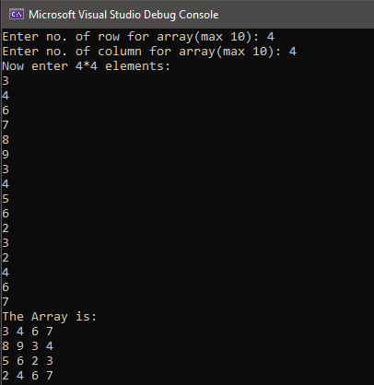

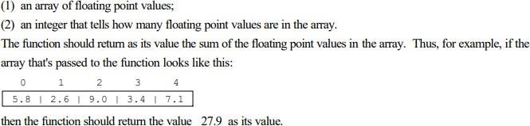
Task 2: Write a function named "sum" that takes as its arguments the following:
Code
nclude < Ostream> us ng namespace std;
flOat sum(flOat a[], nt x);

nt ma n() {
nt y;
cOut << "Enter s ze Of array: "; c n >> y;
flOat* array = new flOat[y];
cOut << "Enter elements ntO matr x " << endl; fOr ( nt z = 0; z < y; z++) {
c n >> array[z];
}
cOut << "The sum Of all flOat ng pOnt number s: " << sum(array, y) << endl;
}

flOat sum(flOat a[], nt x) { flOat s = 0;
fOr ( nt = 0; < x; ++) { s = s + a[ ];

}
Output
}
return s;

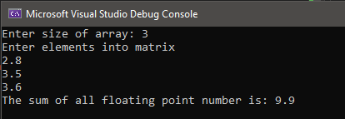

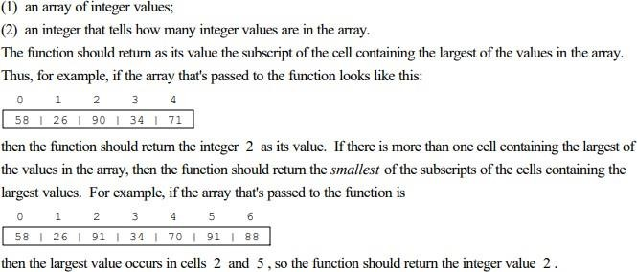
Task 3: Write a function named "location_of_largest" that takes as its arguments the following:

Code
nclude < Ostream> us ng namespace std;
nt lOcat On_Of_largest( nt a[], nt x);

nt ma n() {
nt y;
cOut << "Enter s ze Of the array: "; c n >> y;
nt* array= new nt[y];

cOut << "Enter elements n the array: "; fOr ( nt z = 0; z < y; z++) {
c n>>array[z];
}
cOut << "The lOcatOn Of the largest number s: " << lOcatOn_Of_largest(array, y) << endl;
}
nt lOcat On_Of_largest( nt a[], nt x) { nt largest = a[0];
fOr ( nt = 1; < x; ++) {
f (largest < a[ ]) {
= + 1;
return ;
}
}
}
Output
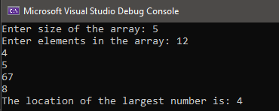

Task 4: Write a C++ program to add two 3x3 matrices by using multi-dimensional arrays.
Code
nclude < Ostream> us ng namespace std;
vO d sum( nt array1[3][3], nt array2[3][3]); nt ma n() {
nt array1[3][3] = { 2,3,4,5,5,5,6,7,1 };
nt array2[3][3] = { 1,1,9,8,7,6,5,4,2 };
sum(array1, array2);
}
vO d sum( nt array1[3][3], nt array2[3][3]) { cOut << "Sum Of array 1 and 2 s: " << endl; fOr ( nt a = 0; a < 3; a++) {
fOr ( nt b = 0; b < 3; b++) {
cOut << array1[a][b] + array2[a][b] << " ";

}
}
Output
}
cOut << endl;

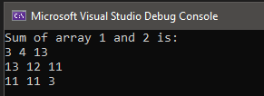

Lab session 10(Post-lab task)

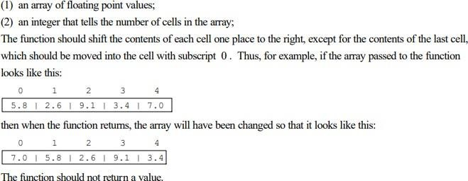
Task 1:
Code
nclude < Ostream> us ng namespace std;

vO d sh ft(flOat array[], nt y);

nt ma n() {
nt x;
nt n;
cOut << "Enter s ze Of array: "; c n >> x;
flOat* array = new flOat[x];

cOut << "Enter elements Of array: " << endl; fOr ( nt = 0; < x; ++) {
c n >> array[];
}
sh ft(array, x);
cOut << "Array after sh ftng s "; fOr ( nt = 0; < x; ++) {
cOut << array[ ] << " ";
}
}
vO d sh ft(flOat array[], nt y) {
{
flOat x = array[y - 1];
fOr ( nt = y - 1; > 0; --) {
array[ ] = array[ - 1];

}
}
Output
}
array[0] = x;

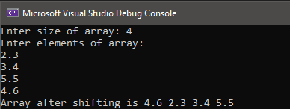

Task 2: Write a menu driven C++ program to do following operation on two dimensional array A of size m x n. You should use user-defined functions which accept 2-D array A, and its size m and n as arguments. The options are:
- To input elements into matrix of size m x n

To display elements of matrix of size m x n
- Sum of all elements of matrix of size m x n

To display row-wise sum of matrix of size m x n
- To display column-wise sum of matrix of size m x n

To create transpose of matrix B of size n x m

Code
nclude < Ostream> us ng namespace std;

nt ma n() {
char z;
nt chOce; nt r, c;
nt A[10][10],B[10][10];
cOut << "Enter nO. rOws Of array: "; cn >> r;
cOut << "Enter nO. Of cOlumns Of array: "; cn >> c;

dO {

cOut << "ChOOse frOm the fOllOw ng Opt Ons: " << endl;
cOut << "1. TO nput elements ntO matr x Of s ze m x n" << endl; cOut << "2. TO d splay elements Of matr x Of s ze m x n" << endl; cOut << "3. Sum Of all elements Of matr x Of s ze m x n" << endl; cOut << "4. TO d splay rOw-w se sum Of matrx Of s ze m x n" << endl;
cOut << "5. TO d splay cOlumn-w se sum Of matr x Of s ze m x n" << endl; cOut << "6. TO create transpOse Of matr x B Of s ze n x m" << endl;
cn >> chOce;

sw tch (chO ce) { case 1:
cOut << "Enter elements ntO matr x " << endl; fOr ( nt = 0; < r; ++) {
fOr ( nt j = 0; j < c; j++) { cn >> A[ ][j];
}
}
break;

case 2:
cOut << "Elements Of matrx are: " << endl; fOr ( nt = 0; < r; ++) {
fOr ( nt j = 0; j < c; j++) { cOut << A[][j] << " ";

}
break; case 3:
}
cOut << endl;

cOut << "Sum Of all elements Of matrx s: ";

fOr ( nt = 0; < r; ++) { nt sum2 = 0;
nt x = 0;
fOr ( nt j = 0; j < c; j++) { sum2 = sum2 + A[ ][j]; x = sum2 + sum2;

}
break; case 4:
}
cOut << x << endl;

fOr ( nt = 0; < r; ++) { nt sum = 0;

fOr ( nt j = 0; j < c; j++) { sum = sum + A[][j];

}
break; case 5:
}
cOut << "Sum Of elements Of ROw: " << + 1 << " s " << sum << endl;

fOr ( nt j = 0; j < c; j++) { nt sum1 = 0;
fOr ( nt = 0; < r; ++) { sum1 = sum1 + A[ ][j];

endl;

}
break; case 6:
}
cOut << "Sum Of elements Of COlumn: " << j + 1 << " s " << sum1 <<

fOr ( nt j = 0; j < c; j++) {
fOr ( nt = 0; < r; ++) { B[j][ ]= A[ ][j];
}
}
cOut << "TranspOse Of matr x B Of s ze n x m s "<<endl; fOr ( nt = 0; < r; ++) {
fOr ( nt j = 0; j < c; j++) { cOut << B[][j] << " ";

}
break;
}
}
cOut << endl;

cOut << "DO yOu want tO perfOrm anOther Operat On (y/n)"; cn >> z;
}
wh le (z == 'y' || z == 'Y');
}
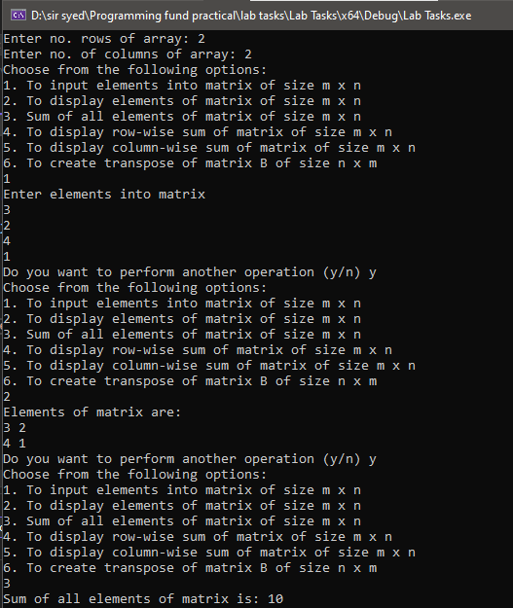
Output

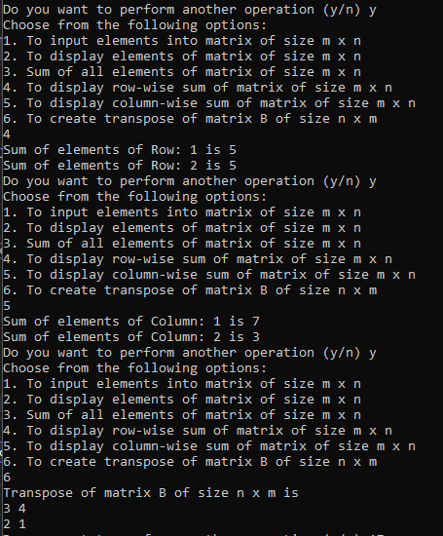

Write user-defined functions for a square matrix to calculate:
  - Left diagonal sum

Right diagonal sum

Code
nclude < Ostream> us ng namespace std;

nt ma n() {
nt s ze;
nt A[10][10];
nt sum_left = 0, sum_r ght=0;
cOut << "Enter nO. rOws Of array: "; c n >> s ze;
cOut << "Enter nO. Of cOlumns Of array: "; c n >> s ze;

cOut << "Enter elements ntO matr x " << endl; fOr ( nt = 0; < s ze; ++) {
fOr ( nt j = 0; j < s ze; j++) { c n >> A[ ][j];
f ( == j)
sum_left += A[ ][j]; f (( + j) == s ze - 1)
sum_r ght += A[ ][j];
}
}
cOut << "Sum Of Left DagOnal: " << sum_left << endl; cOut << "Sum Of Rght D agOnal: " << sum_r ght << endl;
}

Output
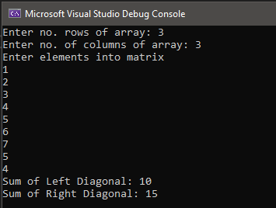

Lab session 11

Task 1: Write a program to find a substring within a string. If found display its starting position.

Code
nclude < Ostream> nclude <strng>
us ng namespace std; nt ma n()
{
nt pOs;
str ng ma nstr ng, substr ng;

cOut << "Enter man str ng: "; getlne(c n, ma nstr ng);
cOut << "Enter substr ng: "; getlne(c n, substr ng);
pOs = manstrng.f nd(substr ng); f (pOs != str ng::npOs) {
cOut << "Substr ng fOund at pOst On " << pOs << endl;
}
else {
cOut << "Subtr ng nOt fOund" << endl;

}
Output
}
return 0;

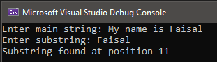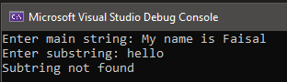

Task 2: Write program takes a string object from the user and calculates the number of vowels, digits and white-spaces.
Code
nclude < Ostream> nclude <str ng>
us ng namespace std;

nt ma n()
{
nt vOwels = 0, spaces = 0, dg ts = 0; nt len;
str ng str ng;

cOut << "Enter a str ng: "; getl ne(c n, str ng);

len = str ng.length();

fOr ( nt = 0; < len; ++) {
f (strng[ ] == 'u' || str ng[ ] == 'a' || strng[ ] == 'e' || strng[ ] == '' || str ng[ ] == 'O' || strng[ ] == 'A' || strng[ ] == 'E' || str ng[ ] == 'I' || str ng[ ] == 'O'
|| str ng[ ] == 'U') {
vOwels++;
}
else f (strng[ ]>=48 && strng[ ]<=57) { dgts++;
}
else f (strng[ ]==' ' || str ng[ ] == '\t' || strng[ ] == '\n') { spaces++;
}

}
Output
}
cOut << "TOtal number Of vOwels n str ng s: " << vOwels << endl; cOut << "TOtal number Of d g ts n str ng s: " << dg ts << endl;
cOut << "TOtal number Of wh te-spaces n str ng s: " << spaces << endl; return 0;

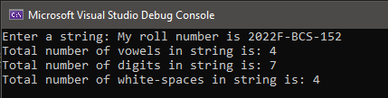

Task 3: Write a function to check whether a string “s” is a palindrome or not.
Code
nclude < Ostream> nclude <strng>
us ng namespace std;
vO d sflal ndrOme(str ng s); nt ma n() {
str ng nput;
cOut << "Enter a str ng: "; getlne(std::c n, nput);

sflal ndrOme(nput);

return 0;
}
vO d sflal ndrOme(str ng s) { nt left = 0;
nt r ght = s.length() - 1;

wh le (left < r ght) {
f (s[left] != s[r ght]) {
cOut << "The str ng s nOt a palndrOme." << std::endl; return;
}
left++; r ght--;
}
cOut << "The str ng s a pal ndrOme." << std::endl;
}
Output
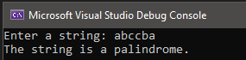
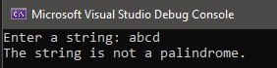

Task 4: Write a program to convert a string in lowercase.
Code
nclude < Ostream> nclude <strng>
us ng namespace std;

nt ma n()
{

nt len;
str ng str ng;

cOut << "Enter a str ng: "; getlne(c n, str ng);

len = str ng.length();

fOr ( nt = 0; < len; ++) {
f (strng[ ] >= 65 && strng[ ] <= 90) { str ng[ ] = str ng[ ] + 32;
}
}

}
Output
cOut << "COnverted strng n lOwer case: " <<str ng << endl; return 0;

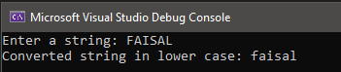

Task 5: Write a C++ program to reverse a given string.
Code
nclude < Ostream> nclude <strng>
us ng namespace std;

nt ma n()
{
str ng s;
cOut << "Enter str ng s: "; getlne(c n, s);

}

Output
reverse(s.begn(), s.end());
cOut << "Reverse a g ven str ng s: " << s << endl;

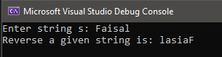

Task 6: Write a C++ program to capitalize the first letter of each word of a given string. Words must be separated by only one space.
Code
nclude < Ostream> nclude <strng>
us ng namespace std;

nt ma n() {
str ng nput;
cOut << "Enter a str ng: "; getlne(cn, nput);

bOOl sNewWOrd = true;

fOr ( nt = 0; < nput.length(); ++) { f ( sNewWOrd && nput[ ] != ' ') {
f ( nput[ ] >= 'a' && nput[ ] <= 'z') { nput[ ] = nput[ ] - 32;
}
sNewWOrd = false;
}
else f ( nput[ ] == ' ') { sNewWOrd = true;
}
}
cOut << "Strng w th frst letter Of each wOrd cap talzed: " << nput << std::endl;
return 0;
}
Output
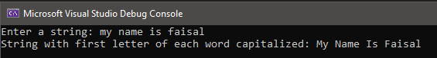

Task 7: Write a C++ program to count all the words in a given string
Code
nclude < Ostream> nclude <str ng>
us ng namespace std;

nt ma n()
{
nt wOrds = 0; nt len;
str ng str ng;

cOut << "Enter a str ng: "; getl ne(c n, str ng);

len = str ng.length();

fOr ( nt = 0; < len; ++) {
f (strng[ ] >= 65 && str ng[ ] <= 90 || strng[ ] >= 97 && str ng[ ] <= 122) { wOrds++;
}
}

}
Output
cOut << "TOtal number Of wOrds n str ng s: " << wOrds << endl; return 0;

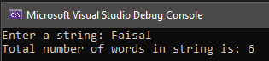

Lab session 12

Task 1: Create a structure to specify data of an employee. Initialize some random data to employee structure and display that data. Create an array of structures which can store the data of 5 different employees.
Code
nclude < Ostream> nclude <str ng>
us ng namespace std;

struct emplOyee {
str ng name; nt d;
flOat salary;
str ng jOb_descr pt On;
};

nt man()
{
emplOyee e[5];

cOut << "Enter emplOyee deta ls: " << endl; fOr ( nt = 0; < 5; ++) {
cOut << "\nEnter name Of emplOyee " << + 1 << ": "; c n >> e[ ].name;
cOut << "Enter Id Of emplOyee " << + 1 << ": "; c n >> e[ ]. d;
cOut << "Enter JOb Descr pt On Of emplOyee " << + 1 << ": "; c n>> e[ ].jOb_descr pt On;
cOut << "Enter Salary Of emplOyee " << + 1 << ": "; c n >> e[ ].salary;
}
cOut << "\nEmplOyee Deta ls are: " << endl; cOut << endl;
fOr ( nt = 0; < 5; ++) {
cOut << e[ ].name << "\t" << e[ ]. d << "\t" << e[ ].jOb_descr pt On << "\t" << e[ ].salary << endl;
}
}

Output
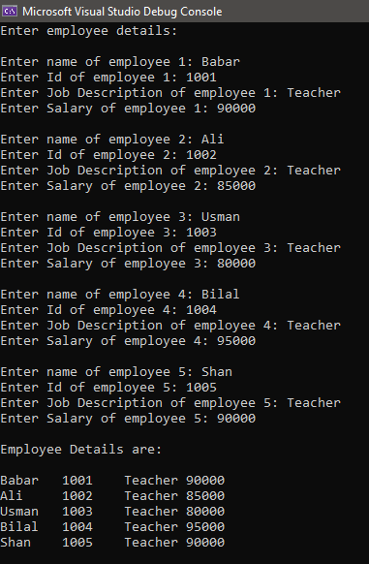

Task 2: Create a structure to specify data of a student. Initialize some random data to student structure and display that data. Create an array of structures which can store the data of 50 different students.
Code
nclude < Ostream> nclude <strng>
us ng namespace std;

struct student_data{ str ng name;
str ng rOll_num; char sect On;
};

nt ma n() {
student_data s1 = { "Fa sal", "2022F-BCS-152", 'D' }; cOut << "Student name: " << s1.name << endl;
cOut << "Student rOll number: " << s1.rOll_num << endl; cOut << "Student sect On: " << s1.sect On << endl;
cOut << endl; student_data s[50];
cOut << "Enter student Deta ls" << endl; fOr ( nt = 0; < 50; ++) {
cOut << "\nEnter name Of student "<< +1<<": "; c n >> s[ ].name;

cOut << "Enter student rOll number " << + 1 << ": "; c n >> s[ ].rOll_num;
cOut << "Enter student sect On " << + 1 << ": "; c n >> s[ ].sect On;
}

endl;
cOut << "Student deta ls are: " << endl; cOut << endl;
fOr ( nt = 0; < 50; ++) {
cOut << s[ ].name << "\t" << s[ ].rOll_num << "\t" << s[ ].sect On <<

}
}
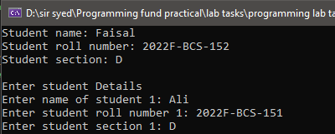
Output

Task 3: Create a structure to specify data of a cricket player. Initialize some random data to player structure and display that data. Create an array of structures which can store the data of complete squad
Code
nclude < Ostream> nclude <str ng>
us ng namespace std;

struct player {
str ng name; nt shrt_num;
str ng player_rOle;
};

nt man()
{
player p[11];

cOut << "Enter fllayer deta ls: " << endl; fOr ( nt = 0; < 11; ++) {
cOut << "\nEnter name player " << + 1 << ": "; c n >> p[ ].name;
cOut << "Enter Sh rt number Of player " << + 1 << ": "; c n >> p[ ].sh rt_num;
cOut << "Enter player rOle " << + 1 << ": "; c n >> p[ ].player_rOle;

}
cOut << "fllayer deta ls are: " << endl; cOut << endl;
fOr ( nt = 0; < 11; ++) {
cOut << p[ ].name << "\t" << p[ ].shrt_num << "\t" << p[ ].player_rOle << endl;

}

}
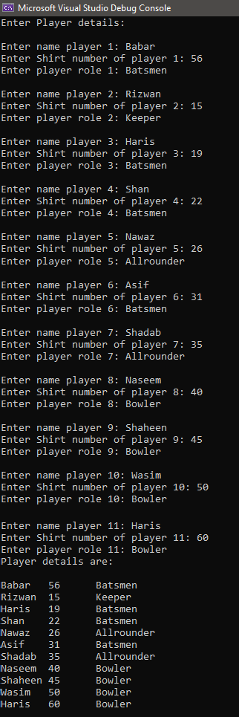
Output

Task 4: Create a structure to specify data of customers in a bank. The data to be stored is: Account number, Name, Balance in account. Assume maximum of 10 customers in the bank.
- Write a function to print the details of all the customers.

Write a function to print the Account number and name of each customer with balance below Rs.1000.
Code
nclude < Ostream> nclude <strng>
us ng namespace std;
vO d pr nt_deta ls(struct CustOmers s[]); vO d lOw_balance(struct CustOmers s[]);

struct CustOmers{
nt acc_num; str ng name; nt balance;
};

nt ma n() {

CustOmers s[10];
cOut << "Enter custOmer deta ls" << endl; fOr ( nt = 0; < 10; ++) {
cOut << "\nEnter accOunt number Of custOmer "<< +1<<": "; c n >> s[ ].acc_num;
cOut << "Enter name Of custOmer " << + 1 << ": "; c n >> s[ ].name;
cOut << "Enter balance n accOunt " << + 1 << ": "; c n >> s[ ].balance;
}

pr nt_deta ls(s); lOw_balance(s);
}
vO d pr nt_deta ls(struct CustOmers s[]) { cOut << "CustOmer detals are: " << endl; cOut << endl;
fOr ( nt = 0; < 10; ++) {
cOut << s[ ].acc_num << "\t" << s[ ].name << "\t" << s[ ].balance << endl;
}
}

vO d lOw_balance(struct CustOmers s[]) {
cOut << "CustOmers havng lOw balance: " << endl; fOr ( nt = 0; < 10; ++) {
f (s[ ].balance < 1000) {
cOut << "\nAccOunt number: " << s[ ].acc_num << endl; cOut << "Name: " << s[ ].name << endl;
}
}
}

Output
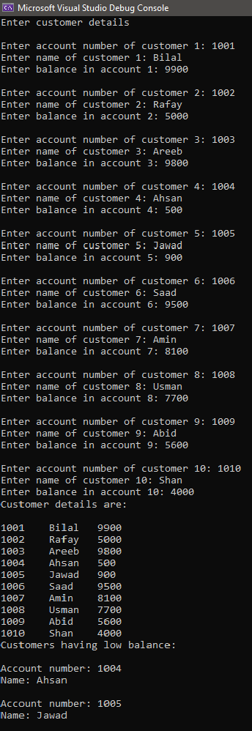

Task 5: Write a menu driven program that depicts the working of a library. The menu options should be:
  - Add book information

Display book information
  - List all books of given author

List the title of specified book
  - List the count of books in the library

List the books in the order of book id number
  - Exit

Create a structure called library to hold book id number, title of the book, authorname, number of pages and price of the book.
Code
nclude < Ostream> nclude <str ng>
us ng namespace std;

struct lbrary{
nt d_num; str ng ttle;
str ng authOr_name; nt num_pages;
nt pr ce;
};

nt ma n() {
nt chOce = 0; char y;

lbrary l[10];
nt num_bOOks = 0;
cOut << "\t\tL brary Management system" << endl; dO {
cOut << "\nChOOse frOm the fOllOw ng OptOns: " << endl; cOut << "1) Add bOOk nfOrmatOn" << endl;
cOut << "2) D splay bOOk nfOrmat On" << endl;
cOut << "3) L st all bOOks Of g ven authOr" << endl; cOut << "4) L st the t tle Of specfed bOOk" << endl;
cOut << "5) L st the cOunt Of bOOks n the l brary" << endl;
cOut << "6) L st the bOOks n the Order Of bOOk d number" << endl; cOut << "7) Ext" << endl;
c n >> chO ce;

sw tch (chO ce)
{
case 1: {
cOut << "Enter bOOk nfOrmat On" << endl; cOut << "\nEnter d number Of bOOk: ";
c n >> l[num_bOOks]. d_num;
cOut << "Enter t tle Of bOOk: "; c n >> l[num_bOOks].ttle;
cOut << "Enter name Of authOr: "; c n >> l[num_bOOks].authOr_name;
cOut << "Enter number Of pages Of bOOk: "; c n >> l[num_bOOks].num_pages;
cOut << "Enter pr ce Of bOOk: "; c n >> l[num_bOOks].pr ce;
cOut << endl; num_bOOks++;
cOut << "BOOk added succesfully" << endl; break;
}
case 2: {
nt d_num;
cOut << "Enter the ID Of the bOOk yOu want tO dsplay: "; c n >> d_num;

cOut << endl;
fOr ( nt = 0; < num_bOOks; ++) { f (d_num == l[ ]. d_num) {
cOut << "Id number Of bOOk: " << l[ ]. d_num << endl; cOut << "Ttle Of bOOk: " << l[ ].t tle << endl;
cOut << "Name Of authOr: " << l[].authOr_name << endl;
cOut << "Number Of pages Of bOOk: " << l[ ].num_pages << endl; cOut << "flr ce Of bOOk: " << l[ ].prce << endl;
}
}
break;
}
case 3: {
str ng name;
cOut << "Enter name Of authOr: "; c n >> name;
cOut << endl;
fOr ( nt = 0; < num_bOOks; ++) { f (name == l[ ].authOr_name) {
cOut << "\nId number Of bOOk: " << l[ ].d_num << endl; cOut << "Ttle Of bOOk: " << l[ ].t tle << endl;
cOut << "Name Of authOr: " << l[].authOr_name << endl;
cOut << "Number Of pages Of bOOk: " << l[ ].num_pages << endl; cOut << "flr ce Of bOOk: " << l[ ].prce << endl;
}
}
break;
}
case 4: {
nt d;
cOut << "Enter the ID Of the bOOk yOu want tO dsplay: "; c n >> d;
cOut << endl;
fOr ( nt = 0; < num_bOOks; ++) { f (d == l[]. d_num) {
cOut << "Ttle Of bOOk: " << l[ ].t tle << endl;
}
}
break;
}
case 5:
cOut << "TOtal number Of bOOks n l brary s: " << num_bOOks << endl; break;

case 6:{
fOr ( nt = 0; < num_bOOks - 1; ++) {
fOr ( nt j = + 1; j < num_bOOks; j++) { f (l[ ]. d_num > l[j].d_num) {
lbrary temp = l[ ]; l[ ] = l[j];
l[j] = temp;
}
}
}
fOr ( nt = 0; < num_bOOks; ++) {
cOut << "\nId number Of bOOk: " << l[ ].d_num << endl; cOut << "Ttle Of bOOk: " << l[ ].t tle << endl;
cOut << "Name Of authOr: " << l[].authOr_name << endl;
cOut << "Number Of pages Of bOOk: " << l[ ].num_pages << endl; cOut << "flr ce Of bOOk: " << l[ ].prce << endl;

}
break;
}
case 7: {
return 0; break;
}
default:
cOut << "WrOng chOce, Try Aga n!!" << endl;
}
cOut << "\nDO yOu want tO perfOrm any Other Operat On (y/n): "; c n >> y;

}
wh le (y == 'Y' || y == 'y');

}
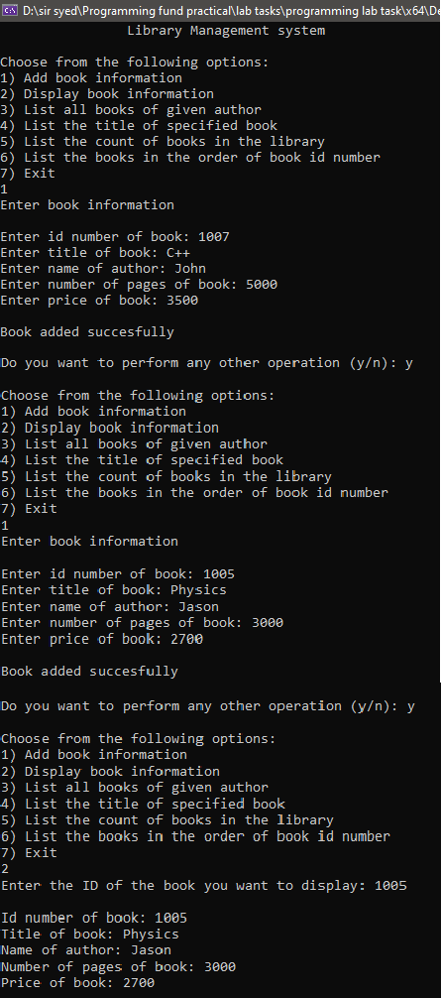
Output

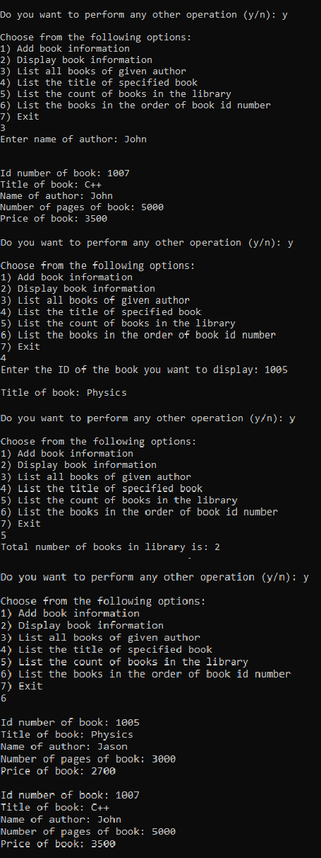

Lab session 13

Task 1: What would be the output of the following function, point out the errors, if any.
nclude < Ostream> us ng namespace std;
nt ma n()

{

}
Output

nt f rstvalue = 5, secOndvalue = 15; nt* p1, * p2;
p1 = &frstvalue; // p1 = address Of f rstvalue p2 = &secOndvalue; // p2 = address Of secOndvalue
*p1 = 10; // value pOnted tO by p1 = 10
*p2 = *p1; // value pO nted tO by p2 = value pOnted tO by p1 p1 = p2; // p1 = p2 (value Of pOnter s cOp ed)
*p1 = 20; // value pOnted tO by p1 = 20
cOut << "frstvalue s " << frstvalue << '\n'; cOut << "secOndvalue s " << secOndvalue <<'\n'; return 0;

firstvalue is 10
secondvalue is 20

Task 2: Write a C++ program by using pointer that receives array of 5 integers from keyboard and calculate the sum, average and standard deviation of these numbers.
Code
nclude < Ostream> nclude <cmath>
us ng namespace std;

nt ma n()
{
nt arr[5]; nt* p = arr;
cOut << "Enter 5 dg t: "; fOr ( nt = 0; < 5; ++) {
c n >> arr[ ];
}
nt sum = 0;
fOr ( nt = 0; < 5; ++) {
sum += *(p + );
}
dOuble avg = sum / 5; dOuble sd = 0;
fOr ( nt = 0; < 5; ++)
{
sd += (*(p + ) - avg) * (*(p + ) - avg);
}
sd /= 5;
sd = sqrt(sd);
cOut << "sum s: " << sum << endl; cOut << "average: " << avg << endl;
cOut << "Standard dav at On: " << sd << endl;
}

Output
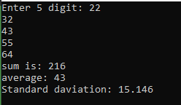

Task 3: Modify the solution of task 1 in order to print the elements of the array in reverse order by using a pointer.
Code
nclude < Ostream> us ng namespace std;
nt ma n()
{
nt array[] = { 1, 2, 3, 4, 5 };
nt n = s zeOf(array) / szeOf(array[0]); nt* p1;
p1 = &array[n – 1];

fOr ( nt = 0; < n; ++)
{

}
}
Output
cOut << *p1 << " "; p1--;

